

**www.DentrixEnterprise.com |** **800.459.8067**

EDR Technical Reference Guide

Indian Health Service (IHS)

Electronic Dental Record (EDR)

Version 4.0

6/21/2023

Contents

A. IHS Business Continuity/Server Backup Plan for EDR (Dentrix Enterprise) 1

1. Overview 1

2. Hardware & General Data Backup Recommendations 2

2.1 Hardware 2

2.2 Redundant Hardware 2

2.3 Operating System 3

2.4 Business Critical Applications 3

EDR Backup 4

2.5 Critical EDR Data, Directories, and Files 4

2.6 Sample Maintenance Plans 5

2.7 Critical Operating System Data Folders and Files 19

2.8 Data Backup Schedule 19

3. Rebuilding EDR and Image Database Server and Hardware Recovery Recommendations and Processes 20

3.1 Hardware 20

3.2 Operating System 20

3.3 Business Critical Applications 20

3.4 Overview of Steps 20

4. Standard EDR Database Maintenance Plan 21

4.1 Recommendations 21

4.2 Certified Database Administrator Recommended 21

4.3 MS SQL Server Documentation 22

5. Detailed EDR Database Backup and Maintenance 22

6. Install SQL Server Instance 24

Appendix A: Support Contact Information 26

B. MiPACS Dental Enterprise (Medicor Imaging) 27

1. System Specifications for MiPACS Dental Enterprise PACS Components 27

1.1 Server Requirements/Recommendations 27

1.2 Desktop Client Requirements/Recommendations 30

1.3 HTML5 Web Viewer Client Requirements/Recommendations 31

1.4 TCP/IP Port Communication Diagram 32

1.5 Network Specifications 33

1.6 Data Backup Information 33

1.7 Antivirus Exclusions: Files/Folders To Exclude 33

1.8 Support Contact Information 33

2. MiPACS Dental Enterprise Viewer 4.0 Installation Instructions 34

2.1 Labelling and Symbols 34

2.2 Introduction 34

2.3 System Requirements 35

2.4 Supported Equipment 36

2.5 Installation 38

2.6 Database Setup 40

2.7 Application Setup 44

2.8 License Management 47

2.9 Plugin Setup 47

2.10 X-ray Imaging System Calibration 51

2.11 Patient Management System Integration 55

2.12 Templates 55

2.13 Upgrading from a Previous MiPACS Version 56

2.14 Problem Solving/Troubleshooting 57

3. MiPACS Business Continuity 59

3.1 EDR MIPACS Business Continuity Software Setup 59

3.2 EDR MIPACS Business Continuity User Setup 61

Appendix B: Component-Specific Instructions 63

B1. Autoimport 63

B2. Belmont BelSensor GOLD 64

B3. Camera WIA 65

B4. Carestream 66

B5. C-Takt Link 67

B6. Dentalmind Digital X-ray II 68

B7. Dürr VistaEasy 69

B8. Export 70

B9. ImageLevel NV SA MDX3 72

B10. Instrumentarium 73

B11. Kavo Gendex 74

B12. Manual Import 75

B13. Medspace 76

B14. Morita 77

B15. Planmeca 78

B16. Schick Intraoral 79

B17. Sirona 80

B18. Soredex 81

B19. TWAIN 82

B20. Video 83

B21. Canon EOS Direct Capture 85

B22. SQL Backup Script 87

B23. Patient Selector 88

B24. Command Line Link 91

Appendix C: Installation Approval Form 94

C. Digital Image Application (DEXIS) 95

1. Overview of Application 95

2. System Requirements 95

3. Basic Network Setup 95

4. Installation Steps 95

5. Data Backup Information 95

6. Antivirus Exclusions 96

7. Support 96

# IHS Business Continuity/Server Backup Plan for EDR (Dentrix Enterprise)

## Overview

The recommendations in this document are guidelines for providing business continuity/disaster recovery for the Electronic Dental Record (EDR) project to be able to provide dental care to your patients and customers should hardware or software failures occur. All policies and procedures for reporting, recovering, and supporting your business’s critical hardware, software, and data should be in accordance with national IHS policies and your local sites policies and procedures to recover systems as efficiently as possible. The guidelines below are for general recovery of hardware and/or software failures. Disasters resulting from natural or environmental events will need to be addressed through your local sites business continuity plan.

The data in your dental database is one of your most valuable resources used in running your dental business. You are responsible for maintaining their database and for ensuring that you have an adequate disaster recovery plan. To accomplish this, you will need trained personnel and the equipment necessary to support your database and to be able to implement your disaster recovery plan (see Appendix A: Support Contact Information). In order to protect your investment, a backup and disaster recovery plan must be developed, implemented, maintained, and tested to protect the data. Processes must be in place to repair hardware as well as recover data and restore/reinstall the associated software needed to run the servers to get systems back on line.

The purpose of this document is to provide general guidelines for a business continuity plan for the EDR in the event of various hardware, software, or disaster events that may disrupt normal business operations. This document will provide overviews, recommendations, and some specific details that can be used to create a disaster recovery plan for the EDR or to merge the EDR into an existing disaster recovery plan.

**However, this document is not intended to provide, nor can it provide, all necessary information, steps, training, and configurations to fully develop and implement a disaster recovery plan**. This document assumes that local IT staff and management will have some existing training and experience with installing, configuring, and supporting IT tools, operating systems, domains, database servers, backup tools, disaster recovery plans, and so forth to implement an effective disaster recovery plan fully and successfully for the EDR.

## Hardware & General Data Backup Recommendations

### Hardware

In order to avoid certain system outages, it is recommended to have redundant or backup hardware whenever possible. It is also recommended that you get hardware maintenance support through the hardware vendor with a 4-hour response time or better. This will assist in the elimination or reduction of extended system outages due to hardware failures and allow you to leverage the existing technology solutions to best serve your patients and customers.

### Redundant Hardware

It is recommended that your hardware solution offer redundancy whenever possible. This includes, but is not limited to, redundant power supplies, various forms of RAID configurations, and extra servers.

#### Remote Vendor Support

Your hardware vendor/manufacturer should have a warranty provided by the manufacturer to assist in resolution of your business-critical hardware. This should include 24x7 responses from a certified hardware and software technician to troubleshoot your issues and then offer recommended and supported solutions. It is recommended that appropriate personnel be aware of and know how to contact and obtain warranty hardware support from their service contract should the need arise.

#### Onsite Vendor Support

Your hardware vendor/manufacturer should dispatch a technician with replacement components to get you up and running within the committed service levels of the manufacturer warranty. Manufacturer warranties (including how to contact the vendor) will be delivered with the server hardware at the time of installation.

### Operating System

#### Discs and Licenses

Original installation CDs and/or DVDs and licenses for the operating system and other purchased products will be delivered with the EDR server hardware. These discs and licenses should be stored in a safe place for use in a disaster recovery situation in order to reinstall the operating system and associated products.

#### OS Files and Data

All critical operating system directories and data files should be backed up to storage media and/or external disk on a nightly basis and should be stored offsite for security purposes. This will ensure the data is available for recovery should a disaster happen with the facility and all systems are lost. These backups will also allow for recovery of corrupt or missing files and/or directories in the case of a minor failure. These could be critical system files, application files, client files, document folders, and so forth. The processes associated with this backup methodology should be in accordance with local business continuity policies.

### Business Critical Applications

#### Application Data

All business critical application data including non‐EDR related applications should be backed up to storage media and/or an external disk (detachable drives) and be stored offsite for security purposes. This will ensure that the data is available for recovery should a disaster happen at the facility that results in a total loss of all systems. The storage media will also allow for recovery of corrupt or missing files and/or directories. These could be critical system files, application files, client files, documents, and so forth. Access to the storage media will allow for quick recovery of the business applications. The processes associated with this backup methodology should be in accordance with local business continuity policies. The restore process should be tested periodically to validate the reliability of the backup solution prior to an emergency occurring.

## EDR Backup

### Critical EDR Data, Directories, and Files

#### EDR Data

The data stored in the EDR database is crucial to providing patient care and running the dental business. Ensuring that a proper EDR data backup plan for each EDR location is in place and working is critical.

#### Initial Backup Configuration

When the database server is delivered for the EDR project, it will come preconfigured with backup plans for both the MS SQL Server and external backups. Training will be provided during the hardware installation to show the local IT personnel how to check these pre‐configured plans. IT personnel can use pre‐configured backup plans as is, or they can modify and/or add items to meet the specific requirements for the site.

#### EDR Server Initial Configuration

When EDR servers are delivered to and installed at the sites, a completed hardware configuration form for that specific server will be supplied to the IT personnel. The IT personnel will want to save this form in a safe location. The hardware configuration form will provide all the details of how the server hardware is configured, such as memory, processor, hard drives, raid configuration, and OS versions.

#### Backup Prerequisites

It is very important to run SQL maintenance plans prior to running your nightly data backups. For those locations that are also storing digital images, you will need to run a maintenance plan for that database as well.

### Sample Maintenance Plans

The following sample, pre-configured MS SQL maintenance plans are for the EDR and Image databases.

#### EDR Database (SQL) Maintenance Plans

1. In SSMS, connect to the Dentrix_Live instance.

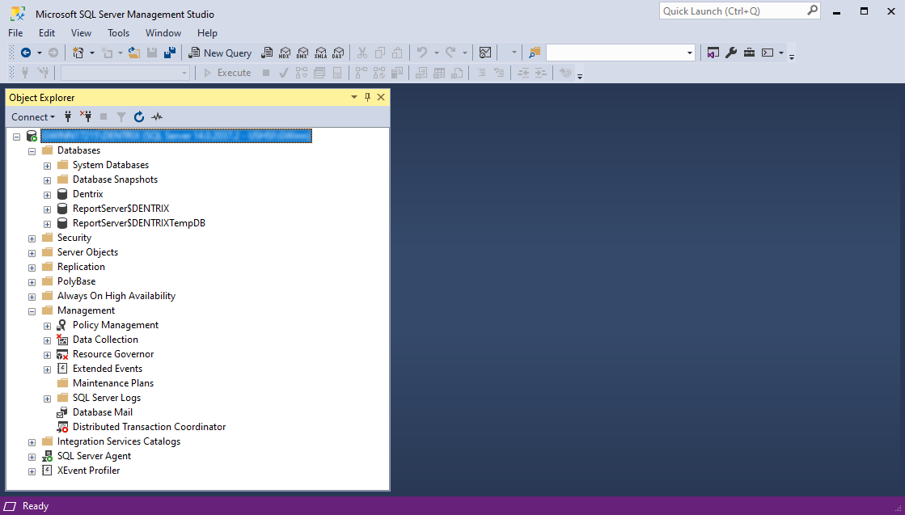

1. On the **Object Explorer** pane, expand **Management**. Right-click **Maintenance Plans**, and then click **Maintenance Plan Wizard**.

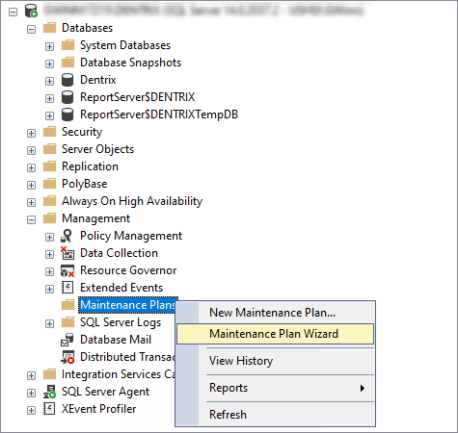

The Maintenance Plan Wizard starts.

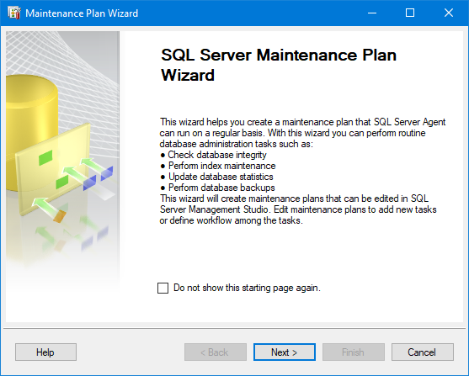

1. Click **Next**.

The **Select Plan Properties** page appears.

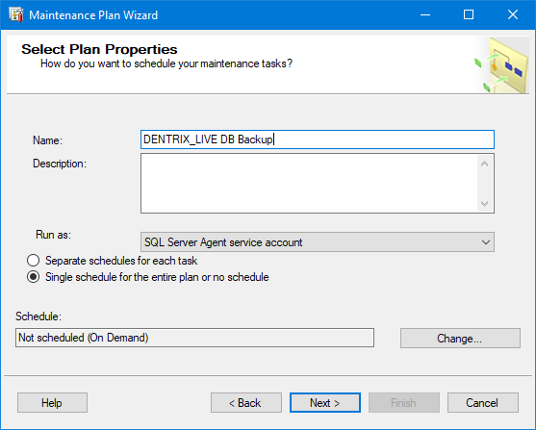

1. In the **Name** box, enter **DENTRIX_LIVE DB Backup**.
2. Next to **Schedule**, click **Change**.

The **New Job Schedule** dialog box appears.

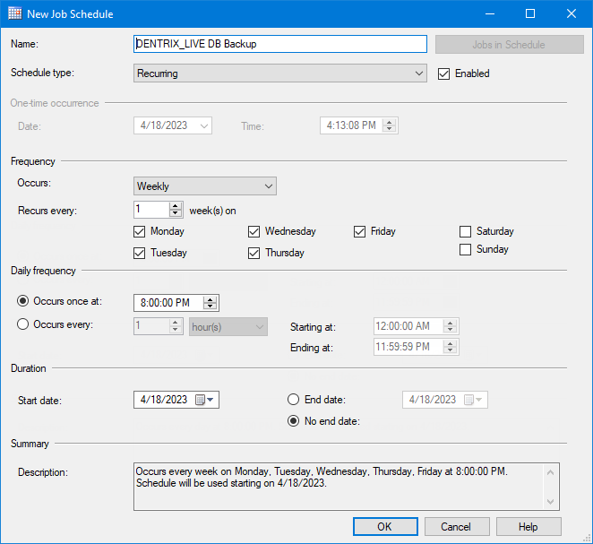

1. Under **Frequency**, select the **Monday**, **Tuesday**, **Wednesday**, **Thursday**, and **Friday** checkboxes.
2. Under **Daily frequency**, with the **Occurs once at** option selected, enter **8:00:00 PM** in the corresponding box.
3. Click **OK**.

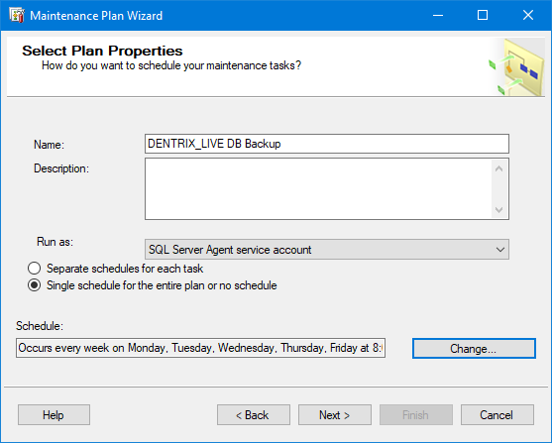

1. Click **Next**.

The **Select Maintenance Tasks** page appears.

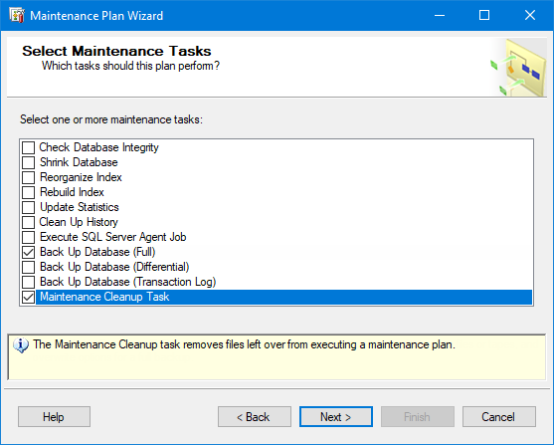

1. In the list, select the checkbox for **Back Up Database (Full)** and the checkbox for **Maintenance Cleanup Task**.
2. Click **Next**.

The **Select Maintenance Task Order** page appears.

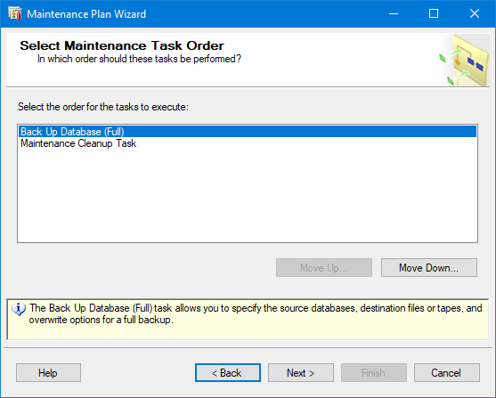

1. Click **Next**.

The **Define Back Up Database (Full) Task** page appears.

1. On the **General** tab, expand the **Database(s)** list, with the **These databases** option selected, select the checkboxes for **Dentrix** and **master**, and then click **OK**.

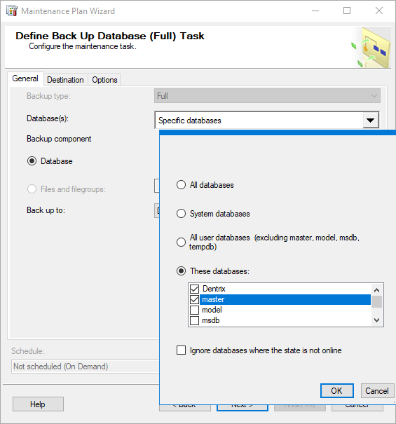

1. On the **Destination** tab, with the **Create a backup file for every database** option selected, click the **Browse** button (...) next to **Folder**, and then select the correct backup directory: **D:\SQLBACKUPS\DENTRIX_LIVE**.

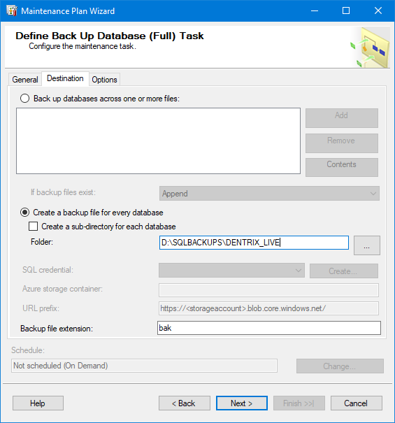

1. In the **Backup file extension** box, enter **bak**.

**Important**: Do not include a dot before the file extension (enter “bak” not “.bak”).

1. Click **Next**.

The **Define Maintenance Cleanup Task** page appears.

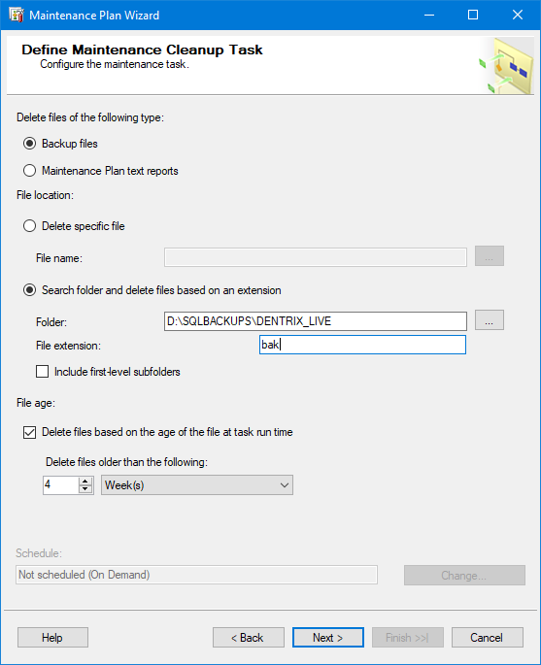

1. With the **Search folder and delete files based on an extension** option selected, click the **Browse** button (...) next to **Folder**, and then select the correct backup directory: **D:\SQLBACKUPS\DENTRIX_LIVE**.
2. In the **File extension** box, enter **bak**.

**Important**: Do not include a dot before the file extension (enter “bak” not “.bak”).

1. Under **File age**, select the **Delete files based on the age of the file at task run time** checkbox. Then, for **Delete files older than the following**, enter **1** in the box, and select **Week(s)** from the list.
2. Click **Next**.

The **Select Report Options** page appears.

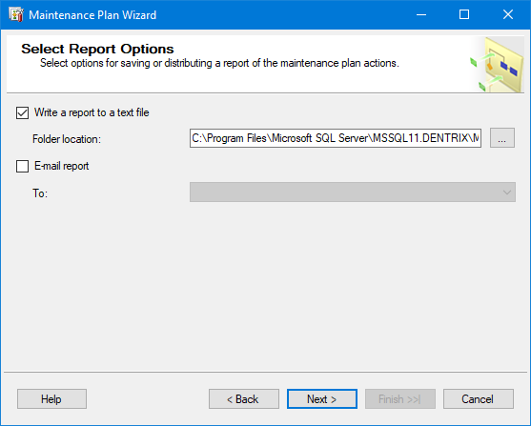

1. Click **Next**.

The **Complete the Wizard** page appears.

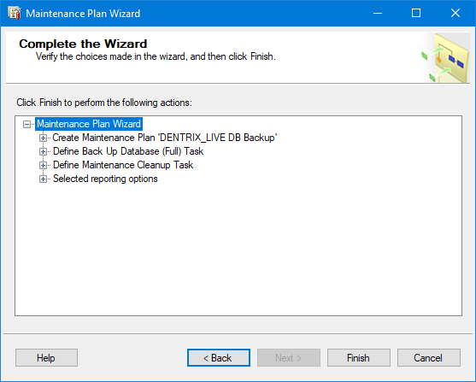

1. Click **Finish**.

The **Maintenance Plan Wizard Progress** page appears.

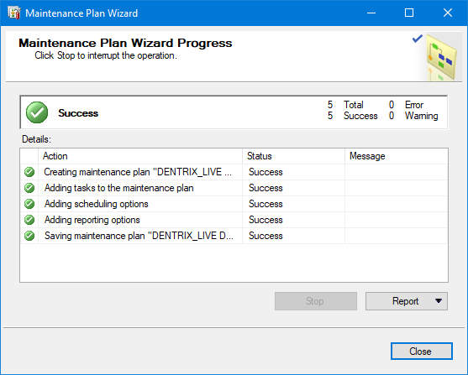

1. After the operations finish, click **Close**.

You are returned to SSMS.

1. On the **Object Explorer** pane, right-click **Maintenance Plans**, and then click **Maintenance Plan Wizard**.

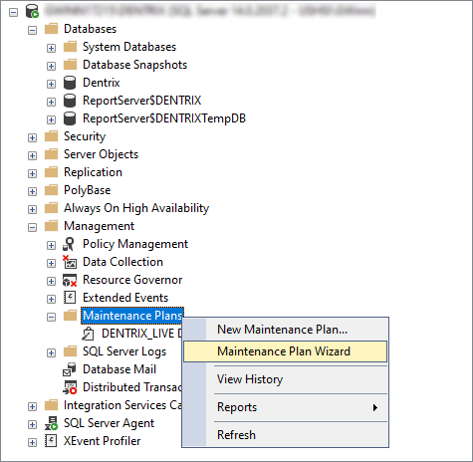

The Maintenance Plan Wizard starts.



1. Click **Next**.

The **Select Plan Properties** page appears.

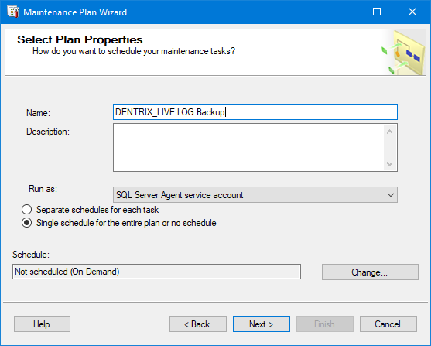

1. In the **Name** box, enter **DENTRIX_LIVE LOG Backup**.
2. Next to **Schedule**, click **Change**.

The **New Job Schedule** dialog box appears.

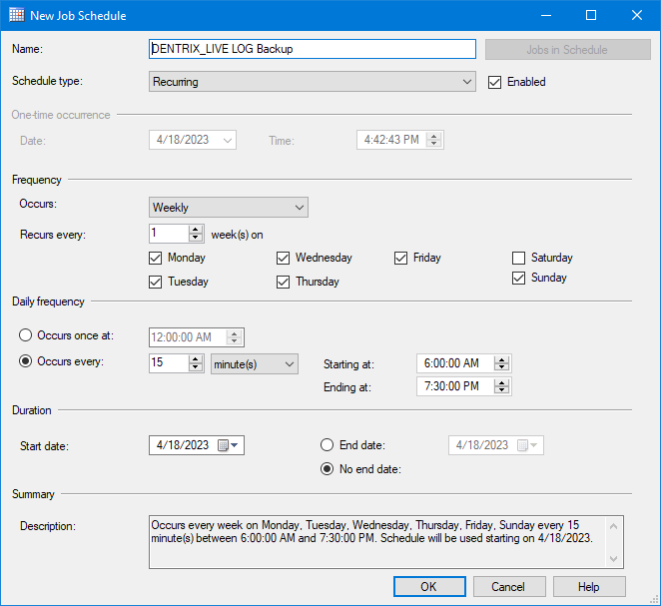

1. Under **Frequency**, select the **Monday**, **Tuesday**, **Wednesday**, **Thursday**, and **Friday** checkboxes.
2. Under **Daily frequency**, select the **Occurs every** option. Then, enter **6:00:00 AM** in the **Starting at** box, and **7:30:00 PM** in the **Ending at** box.
3. Click **OK**.

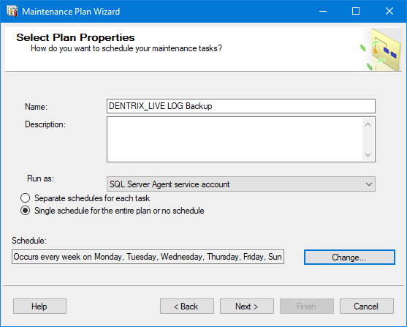

1. Click **Next**.

The **Select Maintenance Tasks** page appears.

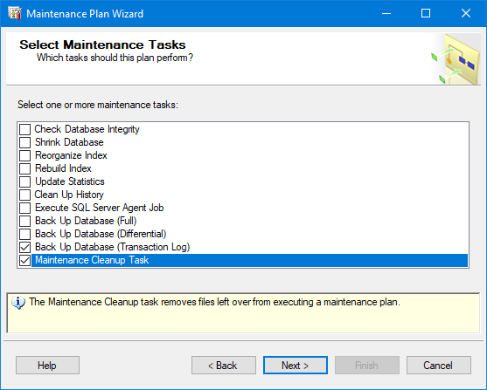

1. In the list, select the checkbox for **Back Up Database (Transaction Log)** and the checkbox for **Maintenance Cleanup Task**.
2. Click **Next**.

The **Select Maintenance Task Order** page appears.

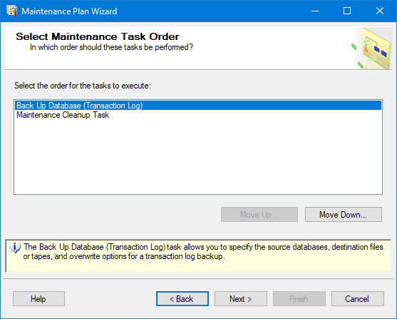

1. Click **Next**.
2. On the **General** tab, expand the **Database(s)** list, with the **These databases** option selected, select the checkbox for **Dentrix**, and then click **OK**.

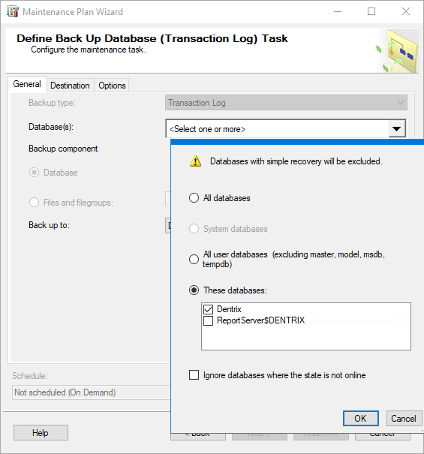

1. On the **Destination** tab, with the **Create a backup file for every database** option selected, click the **Browse** button (...) next to **Folder**, and then select the correct backup directory: **D:\SQLBACKUPS\DENTRIX_LIVE**.

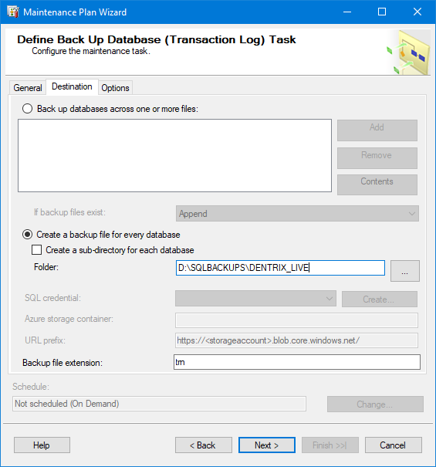

1. In the **Backup file extension** box, enter **trn**.

**Important**: Do not include a dot before the file extension (enter “trn” not “.trn”).

1. Click **Next**.

The **Define Maintenance Cleanup Task** page appears.

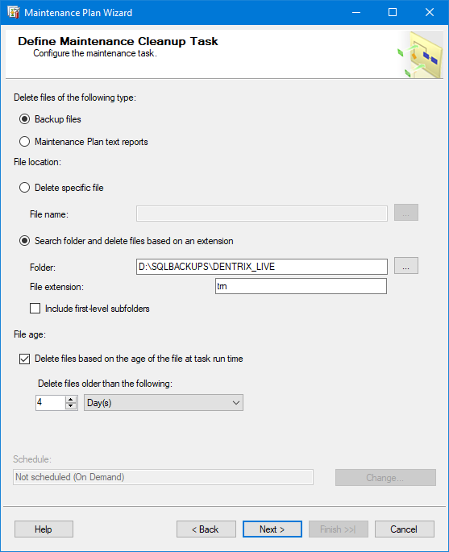

1. With the **Search folder and delete files based on an extension** option selected, click the **Browse** button (...) next to **Folder**, and then select the correct backup directory: **D:\SQLBACKUPS\DENTRIX_LIVE**.
2. In the **File extension** box, enter **trn**.

**Important**: Do not include a dot before the file extension (enter “trn” not “.trn”).

1. Under **File age**, select the **Delete files based on the age of the file at task run time** checkbox. Then, for **Delete files older than the following**, enter **4** in the box, and select **Day(s)** from the list.
2. Click **Next**.

The **Select Report Options** page appears.



1. Click **Next**.

The **Complete the Wizard** page appears.

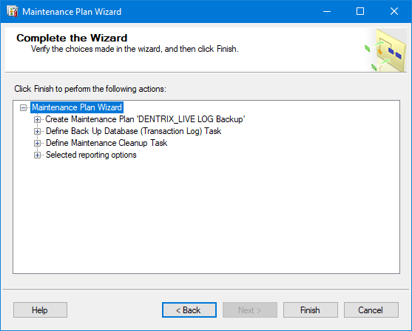

1. Click **Finish**.

The **Maintenance Plan Wizard Progress** page appears.

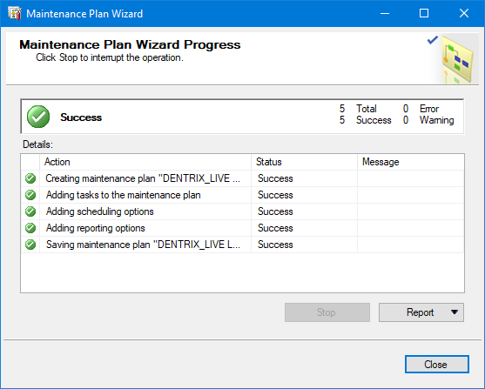

1. After the operations finish, click **Close**.

#### Image Database Maintenance Plans

For either the DEXIS Imaging Suite database or the MiPACS database, follow the same process as explained for the Dentrix Enterprise database.

### Critical Operating System Data Folders and Files

The following are the folders that should be backed up to either a NAS or external media on a nightly basis:

* **Doc_Center** – Folder containing all documents scanned into the Dentrix Enterprise Document Center.
* **DXONE** – Shared writeable folder containing customizations and report templates.
* **Dexis Imaging Suite or TXTOUT, Image store for MiPACS** – Folder containing digital images for the clinic.
* **ORIGINAL** – Folder containing all software and settings needed to reinstall the implementation.
* **SQLBACKUPS** – Folder containing database backups for Dentrix and DEXIS/MiPACS.

Local IT personnel should review their local drives, directories, and files to determine what other data should be backed up and add it to the backup process.

### Data Backup Schedule

It is recommended that critical system and application files be backed up on a nightly basis. Typical schedules will be set to run Monday through Friday after business hours. If the facility is open for business on Saturday or Sunday, a Saturday/Sunday night backup is recommended as well. Every morning the backup logs should be reviewed to confirm a successful backup was completed. If so, the removable media should be disconnected and replaced with the next device. Disconnected backup media should be stored in a fire-safe location onsite or stored at a secure offsite location.

## Rebuilding EDR and Image Database Server and Hardware Recovery Recommendations and Processes

### Hardware

Restoration of physical hardware configurations should follow your local center’s support policy combined with the warranty provided by the hardware vendor. Once you have completed the replacement of failed hardware components, proceed to section 4.2 Operating System.

### Operating System

When reinstalling the base operating system (Windows Server), you should follow your local center’s support policy. This will include the following:

* The loading of the Windows Server operating system.
* The installation of system service packs, drivers, patches, and so forth.
* The configuration of the system (computer name, IP address, network settings, and so forth).

Once the operating system is reinstalled and configured, proceed to section 4.3 Business Critical Applications.

### Business Critical Applications

Restoration of the business applications will follow your local center’s support policy in combination with the following recommendations for the Dentrix Enterprise and imaging software.

### Overview of Steps

**Required software**:

* A copy of the Microsoft Server operating system software (which was delivered with the server) and the necessary service packs.
* A copy of the Microsoft SQL Server database software (which was loaded in the Original folder on the Data partition) and the necessary service packs.
* A copy of the Dentrix Enterprise software (which was delivered with the server).
* A copy of the Image software (which was delivered with the server).

**Installation**:

1. Install the Windows Server OS, and configure the hardware.
2. Install Microsoft SQL Server on the database server.

* Use the SQL Server version appropriate for the version of Dentrix Enterprise in use. Go to <https://www.dentrixenterprise.com/support/requirements> to verify the correct version.
* Install an instance of SQL Server for Dentrix Enterprise (see section 7. Install SQL Server Instance).

1. Restore the SQL maintenance plans (see section 3.2 Sample Maintenance Plans):

* Restore the Dentrix Enterprise maintenance plan from the backup media to a TEMP directory.
* Restore the Image maintenance plan from the backup media to a TEMP directory.
* Restore the files from the TEMP directory to the SQL instance.

1. Contact Dentrix Enterprise Support (800) 459‐8067 for assistance running scripts to restore the database.
2. If the images are on the same server as the database, the images folder must be restored from the backup media as well.
3. Install the Dentrix Enterprise software.
4. Install the Image software.

## Standard EDR Database Maintenance Plan

### Recommendations

The data in your EDR dental database is one of your most valuable resources that are used in running your dental business. You are responsible for maintaining their database and for ensuring that you have an adequate disaster recovery plan. To accomplish this, you will need trained personnel and the equipment necessary to support your database and to be able to implement your disaster recovery plan. In order to protect your investment, a disaster recovery plan needs to be developed, implemented, maintained, and tested.

This section provides general maintenance items that you should review with your database administrator (DBA) to create a plan to protect and secure your database server and data. Your plan may need to be customized to fit your needs and your environment.

### Certified Database Administrator Recommended

It is recommended that your DBA should be a Microsoft Certified Solutions Associate (MCSA) for SQL Database Administration. A trained and qualified MCSA Database Administrator will already know how to accomplish the tasks listed in this document. The best tool to implement and track your maintenance plan is the MS SQL Server Management Studio, which is available for download from <https://docs.microsoft.com/en-us/sql/ssms/download-sql-server-management-studio-ssms?view=sql-server-ver15>.

### MS SQL Server Documentation

The following link is for all versions of MS SQL Server: <https://docs.microsoft.com/en-us/sql/sql-server/?view=sqlallproducts-allversions>. A trained DBA will already be familiar with this information, but you are encouraged to visit the link to learn what is best for you.

## Detailed EDR Database Backup and Maintenance

**Note**: Clicking any link presented will take you to the corresponding MS SQL documentation that describes the applicable concepts and features and provides detailed instructions for completing the task.

We recommend using the following items as part of your plan:

* **Have a backup and restore plan for all databases** – You need to create a plan to protect your data in case of disaster (equipment failure, employee sabotage, fire, and so forth). Determine what recovery plan is best for you. See <https://docs.microsoft.com/en-us/sql/relational-databases/maintenance-plans/maintenance-plans?view=sqlallproducts-allversions>.
* **Create MS SQL maintenance plans** – One of the easiest ways to implement the backup portion of this plan is to create a database maintenance plan using the MS SQL Database Maintenance Plan Wizard. See <https://docs.microsoft.com/en-us/sql/relational-databases/maintenance-plans/use-the-maintenance-plan-wizard?view=sqlallproducts-allversions>.
* **Create a full database backup for key events** – A full database backup should be created for key events after the initial database setup for any live, test, or training Dentrix databases. These events include initial install, go live, upgrading versions, and so forth.
* **Back up and truncate transaction logs** – Back up and truncate transaction logs on a daily basis to keep them small.

**Important**: When SQL Server finishes backing up the transaction log, it automatically truncates the inactive portion of the transaction log. This inactive portion contains completed transactions and is no longer used during the recovery process. Conversely, the active portion of the transaction log contains transactions that are still running and have not yet completed. SQL Server reuses this truncated, inactive space in the transaction log instead of allowing the transaction log to continue to grow and use more space. Although the transaction log may be truncated manually, it is strongly recommended that you do not do this as it breaks the log backup chain. Until a full database backup is created, the database is not protected from media failure. Use manual log truncation only in very special circumstances, and create a full database backup as soon as it is practical.

* **Back up the live EDR database every day** – You can use any of the following methods to back up:
  + You can use the MS SQL Management Studio and MS SQL Server Agent to backup directly to media.
  + You can use the MS SQL Server Agent with your backup program to stop the database, do the backup, and then restart the database.
  + You can use the MS SQL Server Management Studio to schedule backups to a flat file. This flat file can then be backed up with your backup program. This file can be copied or backed up to another machine as well.

**Note**: Many backup systems cannot effectively or directly backup MS SQL databases. If the MS SQL Server engine is running, the files that make up the database are locked, and many backup media systems cannot backup the locked database files from outside of the Microsoft SQL Server Management Studio. These backup solutions may see that the database files are in use and skip those files.

* **Check server drive space** – The servers should be checked weekly or monthly to ensure that you have adequate available free disk space for the growth of the live database files, transaction logs, and backup files. When EDR databases are installed, by default, they are configured to pre‐allocate an adequate portion of space on your server hard drives to store the database and transaction logs. The databases are also configured such that the size of the database and transaction log files will grow automatically as needed once the initial pre‐allocated space is filled and will continue to grow until the hard drive is full. Use the operating system to check the free space on drives.
* **Store database backups offsite** – Database backups should be performed weekly or monthly and stored offsite in a secure location. In you plan, you may want to incorporate a 3 to 6 month rotation of the backups stored offsite.
* **Shrink and defragment databases** – The live databases should be shrunk and defragmented (moving pages internally to the beginning of the files that make up the database) using the MS SQL Server tools monthly or after significant deletions of data in the database (purging appointments, purging old audit records, and so forth). Also, the EDR server hard drives containing the database should be defragmented on a regular basis at the operating system level using the operating system defragmenting tools. This defragmenting of the database files at the operating system level will ensure optimal data layout on the drives to enhance database performance.
* **Monitor EDR database performance statistics** – EDR Database performance statistics should be checked monthly or semi‐annually to ensure proper server performance.
* **Rebuild database indexes** – Database indexes should be rebuilt semi‐annually or annually to ensure optimal index performance. Contact Dentrix Enterprise Support at (800) 459‐8067. This will usually be done as you upgrade to new versions of Dentrix Enterprise as they become available.
* **Install patches for OS and SQL Server** – Check monthly with Microsoft for updates to your Windows operating system and MS SQL Server to make sure that you have the latest patches and fixes from them. If you are using any other third-party products, you should do the same for those. Use the Microsoft Update websites to look for, download, and install patch updates for the Windows Server Operating System and MS SQL Server database engine.
* **Evaluate EDR server hardware capacity and performance** – The database server hardware should be evaluated every 6 months to 1 year or at other significant events (adding significantly more users to the database, hosting more locations, and so forth) to check if the hardware is handling the needs of the EDR server (processor speed, amount of memory, hard drive speed, available space on the hard drive, and so forth).

## Install SQL Server Instance

To demonstrate the installation of a “DENTRIX_LIVE” instance of SQL Server, SQL Server 2019 Standard will be used in the following steps. Adjust folder locations to your server configuration, and create and document your own SA (System Administrator) password.

1. In File Explorer, navigate to **D:\Original\SQL Server 2019 Standard**, and then double-click **setup.exe**.

The **SQL Server Installation Center** window appears.

1. On the left, select **Installation**, and then click the **New SQL Server stand-alone installation or add features to an existing installation** link.

The SQL Server 2019 Setup starts, and the **Product Key** page appears.

1. Leave the **Enter the product key** option selected and the product key entered, and then click **Next**.

The **License Terms** page appears.

1. Select the **I accept the license terms and Privacy Statement** checkbox, and then click **Next**.

The **Global Rules** page appears only if there are rule errors.

The **Microsoft Update** page appears only if the **Microsoft Update** checkbox is not selected in **Control Panel** > **All Control Panel Items** > **Windows Update** > **Change settings**. Selecting that check box allows Windows Updates to include the latest updates for all Microsoft products when you scan for Windows updates.

The **Product Updates** page appears only if SQL Server product updates are available.

The **Install Setup Files** page appears.

1. Setup provides the progress of downloading, extracting, and installing the Setup files. If an update for Setup is found and you specify to include it, that update will also be installed. If no update is found, Setup will automatically advance.

The **Install Rules** page appears.

1. If no potential problems are detected, click **Next**.

The **Installation Type** page appears only if SQL Server is already installed on the system.

The **Feature Selection** page appears.

1. Select the following features:

* **Database Engine Services**.
* **SQL Server Management Studio**.
* **SQL Server Configuration Manager**.
* **Connectivity Components**.

1. Change the following installation directories:

* **Instance root directory** – Enter **D:\DENTRIX_LIVE**.
* **Shared feature directory** – Enter **D:\Program Files\Microsoft SQL Server\**.
* **Shared feature directory (x86)** – Enter **D:\Program Files (x86)\Microsoft SQL Server\**.

**Note**: Each of these paths must be different.

1. Click **Next**.

The **Feature Rules** page appears only if not all rules pass.

The **Instance Configuration** page appears.

1. Select the **Named instance** option, and then enter **DENTRIX_LIVE** in the corresponding box.
2. In the **Instance ID** box, enter **DENTRIX_LIVE**.
3. Click **Next**.

The **Server Configuration** page appears.

1. For the **SQL Server Agent** and **SQL Server Database Engine** services, leave **NT Service** as the **Account Name**.
2. Make sure that the **Startup Type** for each service is set to **Automatic**.
3. Click **Next**.

The **Database Engine Configuration** page appears with the **Server Configuration** tab selected.

1. Under **Authentication Mode**, select the **Mixed Mode** option, and then enter **Ch@ngeM3** in the **Enter password** and **Confirm password** boxes.
2. Under **SQL Server Administrators**, click **Add Current User**.

**Note**: **[Server name]\_Administrator (_Administrator)** should appear in the list. _Administrator should be part of the Administrators group.

1. Select the **Data Directories** tab.
2. Change the following directories:

* **Data root directory** – Enter **D:\DENTRIX_LIVE\**.
* **User database directory** – Enter **D:\DENTRIX_LIVE\DATA**.
* **User database log directory** – Enter **D:\DENTRIX_LIVE\LOG**.
* **Backup directory** – Enter **D:\SQLBACKUPS\DENTRIX_LIVE**.

1. Select the **TempDB** tab.
2. Add the following directory to the **Data directories** list: **D:\DENTRIX_LIVE\TEMP**.

**Note**: This should be the only directory in the list.

1. Click **Next**.

The **Feature Configuration Rules** page appears only if there are rule errors.

The **Ready to Install** page appears.

1. Verify that the information is correct, and then click **Install**.

When the installation is complete, the **Complete** page appears.

1. Click **Close**.
2. Click the **X** in the upper-right corner of the **SQL Server Installation Center** window.

## Appendix A: Support Contact Information

* **Dell Pro Support** – Covers Dell hardware. Call (866) 876-3355.
* **Microsoft support** – Covers MS products. Visit <https://support.microsoft.com/en-us>.
* **Dentrix Enterprise support** – Covers EDR/Dentrix Enterprise software. Call (800) 459-8067.
* **Tech Central** – Can coordinate with all of the above. Call (877) 483-0382.

# MiPACS Dental Enterprise (Medicor Imaging)

## System Specifications for MiPACS Dental Enterprise PACS Components

MiPACS Dental Enterprise PACS is a modular, scalable dental PACS that can be implemented in a number of ways, depending on the requirements and standard technology practices of an organization. MiPACS can be implemented on both physical hardware and as a virtual server (using any virtualization platform). Recommendations for both are included below, but we recommended that you consult with your MiPACS project manager for implementation recommendations for your particular environment.

**Medicor Imaging Software Versions**

The specifications provided below and on the following pages are for the following product versions:

|  |  |
| --- | --- |
| * MiPACS Storage Server | v3.0.0.0 |
| * MiPACS HTML5 Web Viewer | 3.0.0.0 |
| * MiPACS Dental Enterprise Viewer | v4.1.0.0 |

### Server Requirements/Recommendations

#### General Information and Requirements

Environments where there are fewer than 50 concurrent DICOM connections can operate on a single MiPACS application server. A DICOM connection is defined as one of the following:

* An active download of images from the MiPACS server
* An active storage of images to the MiPACS Server.
* An active query to the DICOM database or Modality Worklist.

Viewing images, manipulating image content, measuring, and so forth do not count as DICOM connections. Only active DICOM uploads, downloads, and queries count as DICOM connections. Generally speaking, 50 concurrent DICOM connections is adequate for up to 1,000 users.

#### Hardware Specifications

|  |
| --- |
| **MiPACS Storage Server Minimum System Physical Configuration**   * Microsoft® Windows Server 2012, 2016, or 2019 (64-bit) * Microsoft® SQL Server Standard Edition 2012, 2014, 2016, 2017, or 2019 * 2.4GHz Intel Xeon 6+ core processor * 16 GB RAM * 100 Mbps Network Adapter (1 Gbps highly recommended) * Microsoft® .NET Framework 4.0+ * Adequate storage for images (variable) |
| **MiPACS Storage Server Recommended Virtual Configuration**   * Microsoft® Windows Server 2012, 2016, or 2019 (64-bit) * 4 Cores * 16 GB RAM * Microsoft® .NET Framework 4.0 * Adequate storage for images (variable) |
| **SQL Server Recommended Virtual Configuration**   * Microsoft® Windows Server 2012, or 2016 (32- or 64-bit) * Microsoft® SQL Server Standard Edition 2012, 2014, 2016, 2017, or 2019 * 4 Cores * 16 GB RAM * Adequate Storage for database files (5 GB+, variable) |
| **MiPACS Storage Server MiniPACS Minimum System Configuration**   * <=10 Clients: Microsoft® Windows 7, 8, or 10 Professional (64-bit) * >10 Clients: Microsoft® Windows Server 2012, or 2016 (64-bit) * Microsoft® SQL Server Express Edition 2012, 2014, 2016, 2017, or 2019 * Intel i3/i5/i7 processor * 8GB RAM or more (16 GB RAM recommended) * 100 Mbps Network Adapter (1 Gbps highly recommended) * Microsoft® .NET Framework 4.0+ * Adequate Storage for Images (variable) |
| **MiPACS HTML5 Web Viewer Server Minimum System Configuration**   * Microsoft® Windows Server 2012, or 2016 (64-bit) * Microsoft® Internet Information Services 7+ * 8GB + 64MB memory per concurrent user (for example, 60 concurrent users would require 12GB RAM) * 8 core Xeon Processor (or more) * Microsoft® .NET Framework 4.0+ * A video card that supports DirectX 9+ must be installed on the Web server to enable hardware- based 3D rendering * Total number of concurrent users available for hardware rendering will vary depending on the field of view and resolution of each volume loaded at once, but generally speaking, 256MB RAM per expected concurrent user is a good target specification for the build-out of a new server * If no graphics card (or an underperforming graphics card) is available on the server, or if there is no remaining member on the graphics card, CPU rendering will be used * Recommended video cards (on server):   + Nvidia GTX 1080 (8GB)   + Nvidia RTX 2080 Ti (12GB) * There are no 3D graphics requirements on the client side (Web browser) |

#### Load Balancing the MiPACS Storage Server

We recommended that you operate MiPACS in a load-balanced environment when there are more than 100 concurrent DICOM connections to the MiPACS Application Server. You may use Microsoft Network Load Balancing (Windows Server 2003–2016), hardware load-balancing appliances, or virtual load-balancing appliances to spread the network load across multiple PACS Server nodes. Note that any load-balancing appliances must be able to forward the client IP to the MiPACS server as the originating/source IP address. This is typically accomplished by configuring the appliance to include the “Forwarded” and/or “X-Forwarded-For” HTTP header.

#### Load Balancing the HTML5 Web Viewer Server

The MiPACS HTML5 viewer may be load balanced but not clustered. You may use Microsoft Network Load Balancing (Windows Server 2003–2016), hardware load-balancing appliances, or virtual load-balancing appliances to spread the network load across multiple Web server nodes. Note that any load- balancing appliances do not require identification of the originating client IP and can simply be load balanced as a standard service.

#### Clustering

For environments using physical server hardware with high uptime requirements, you can implement MiPACS in an active/active cluster using Microsoft Clustering Services (Windows Server 2003–2016 Enterprise Edition only). An active/active MiPACS cluster consists of two separate cluster resource groups: one for the MiPACS Storage Server DICOM services, and one for Microsoft SQL Server (Microsoft SQL Server Standard Edition or higher is required). We do not recommend that you cluster virtual MiPACS and/or database servers due to better and more responsive redundancy typically being built into the virtual platform infrastructure.

### Desktop Client Requirements/Recommendations

The MiPACS client is a relatively lightweight client desktop application for Microsoft Windows operating systems. It has no prerequisites and can be installed on virtually any relatively modern Windows computer.

|  |
| --- |
| **4.1 or later MiPACS Dental Enterprise Viewer Minimum System Configuration**   * Microsoft® Windows 8/10 Professional (32- or 64-bit)* * Intel i3/i5/i7 Processor * 4 GB RAM (8 GB recommended) * 100 Mbps Network Adapter (1 Gbps recommended) * XVGA 1024x768 at 24/32 bit color (SXGA 1280x1024 recommended) * Monitor with at least 400:1 contrast ratio (800:1 or higher recommended)   * Please note that capture devices may come with their own requirements, which are separate from the requirements of the MiPACS software. Please consult with the device manufacturer of each device for operating system compatibility. |
| **3.2 to 4.0 MiPACS Dental Enterprise Viewer Minimum System Configuration**   * Microsoft® Windows 7/8/10 Professional (32- or 64-bit)* * Intel i3/i5/i7 Processor * 4 GB RAM (8 GB recommended) * 100 Mbps Network Adapter (1 Gbps recommended) * XVGA 1024x768 at 24/32 bit color (SXGA 1280x1024 recommended) * Monitor with at least 400:1 contrast ratio (800:1 or higher recommended)   * Please note that capture devices may come with their own requirements, which are separate from the requirements of the MiPACS software. Please consult with the device manufacturer of each device for operating system compatibility. |
| **3.1.1404 or earlier MiPACS Dental Enterprise Viewer Minimum System Configuration**   * Microsoft® Windows XP/7/8/10 Professional (32- or 64-bit)* * Intel i3/i5/i7 Processor * 4 GB RAM (8 GB recommended) * 100 Mbps Network Adapter (1 Gbps recommended) * XVGA 1024x768 at 24/32 bit color (SXGA 1280x1024 recommended) * Monitor with at least 400:1 contrast ratio (800:1 or higher recommended)   * Please note that capture devices may come with their own requirements, which are separate from the requirements of the MiPACS software. Please consult with the device manufacturer of each device for operating system compatibility. |

### HTML5 Web Viewer Client Requirements/Recommendations

The MiPACS HTML5 Web Viewer is a completely zero-footprint dental/medical viewer, which requires no installation of any applications, controls, or plug-ins. It functions within a Web browser only, so connectivity to the server is required for all operations.

|  |
| --- |
| **MiPACS HTML5 Web Viewer Minimum System Configuration**   * Any operating system (Windows, MacOS, Linux, iOS, Android, and so forth) * Any HTML5-compliant Web browser (Internet Explorer, Chrome, Edge, Safari, Opera, and so forth) * Access to the MiPACS HTML5 Viewer server requires at least a 1Mbps network connection |

#### Load Balancing

The MiPACS HTML5 viewer may be load balanced but not clustered. You may use Microsoft Network Load Balancing (Windows Server 2003–2016), hardware load-balancing appliances, or virtual load-balancing appliances to spread the network load across multiple Web server nodes. Note that any load- balancing appliances do not require identification of the originating client IP and can simply be load balanced as a standard service.

### TCP/IP Port Communication Diagram

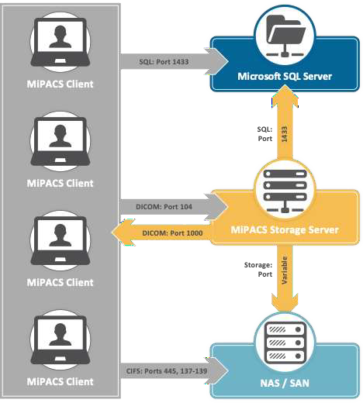

### Network Specifications

|  |  |  |
| --- | --- | --- |
| **Configuration** | **Minimum Bandwidth** | **Recommended Bandwidth** |
| Clients directly communicating with server on same local network | 100Mbps | 1000Mbps |
| Clients directly communicating with server over a wide area network (local database–SQL or Access) | 10Mbps | 50Mbps |
| MiniPACS server communicating with central server over a wide area network | 1.5Mbps | 10Mbps |

### Data Backup Information

* SQL Server database files (*.mdf, *.ldf)
* MiPACS Storage Server image share folder
* MiPACS Viewer image share folder

### Antivirus Exclusions: Files/Folders To Exclude

* MiPACS Storage Server image share folder
* MiPACS Viewer image share folder
* C:\Program Files (x86)\MiDentView
* C:\ProgramData\Medicor Imaging
* X:\Medicor Imaging\MiPACS Storage Server

### Support Contact Information

Phone: 704-227- 2629

Website: <https://medicorimaging.com/support/> Email: [support@medicorimaging.com](mailto:support@medicorimaging.com)

## MiPACS Dental Enterprise Viewer 4.0 Installation Instructions

### Labelling and Symbols

|  |  |
| --- | --- |
| icon | **Manufacturer**:  Medicor Imaging, Inc.  1927 South Tryon Street, Suite 200 Charlotte, NC 28203 U.S.A.  Tel: +1-704-227-2629  Fax: +1-704-372-8161  Email: [support@medicorimaging.com](mailto:support@medicorimaging.com)  Website: [www.medicorimaging.com](http://www.medicorimaging.com/)  The **date of manufacture** appears in the software. |
| icon | **Read all instructions before use**! |
| icon | **The catalog number is MiPACS Dental Viewer 4.0**.  Current product version appears in the software (MiPACS Dental Viewer 4.0.x). This version of the installation instructions is valid for product versions from MiPACS Dental Viewer 4.0.x. |
| icon | **Warning**!  This symbol alerts the user to the risk of possible injury, death, or other serious adverse reactions. |
| icon | **Caution**!  Instructions with this symbol must be followed in order to ascertain proper function of the equipment. |

### Introduction

MiPACS 4.0 is an image management software for dental practices. Before the MiPACS software products can be put to clinical use, you must properly install and configure it according to the installation instructions in this document.

Installation and configuration is not intended to be performed by an end-user, but by an authorized MiPACS representative or an IT technician with experience in installing software and hardware for use in dental practices.

Follow the “Installation Instructions” together with the “Instructions for Use.” Both documents are distributed with the software and are also available from the distributor or Medicor Imaging. Please refer to the Instructions for Use regarding product description, regulatory information, intended use and details regarding the user interface and clinical use of the product.

Before installing and configuring software components, please consult sections 2.3 System Requirements and 2.4 Supported Equipment to establish that the product is suitable for the intended use and compatible with the available equipment.

### System Requirements

#### Workstation System Requirements

The recommended computer hardware for a workstation running MiPACS Dental Viewer 4.0:

* Processor: Intel Core i3-compatible or better
* RAM: 4GB
* Disk: 40GB available
* Network adapter: 1 Gbit/s
* Screen resolution: 1280x1024, 32-bit color or better
* A medical display monitor, (DICOM monitor) is strongly recommended. Alternatively, a high- quality display, properly calibrated, may be used if image rendering is considered acceptable for clinical use.

MiPACS Dental Viewer 4.0 is supported on the following operating systems:

* Microsoft® Windows 7, 32-bit or 64-bit
* Microsoft® Windows 8.1, 32-bit or 64-bit

For security reasons, the Windows operating system should be updated with the latest service packs and Windows updates. Use of antivirus software and firewalls is also recommended, but such software must be properly configured to not interfere with MiPACS and image transfer over the network.

The “Instructions for Use” and the “Installation Instructions”(provided in this document) are installed as .pdf files that can be opened from the Start menu or in the application. To view these .pdf files, a PDF Viewer, such as Adobe Acrobat, must be installed on the computer.

MiPACS can be installed with optional software modules (plugins) to connect MiPACS with third-party hardware (such as sensors and cameras), with software (such as other imaging applications or patient management systems), and with services (such as image transferring).

The third-party hardware and software and the plugins may have different system requirements than those listed above. For example, some sensors may work in 32-bit Windows but not in 64-bit. Applicable additional system requirements for each plugin appear in Appendix B: Component-Specific Instructions. It is important to verify that any hardware that is to be used with MiPACS is supported by the plugin and that the driver version is compatible with MiPACS and with the operating system.

#### Database Server and Network System Requirements

MiPACS Dental Viewer 4.0 requires a database running on Microsoft® SQL Server 2012. It is not necessary to install MiPACS Dental Viewer 4.0 on the database server.

For best reliability and performance, we recommend that you connect workstations and servers in an Ethernet network that utilizes network adapters, switches, and cables that support at least 1Gbps bandwidth.

We recommend that you run MiPACS in a Windows domain, but the system can work on a single computer or in a peer-to-peer network as well. MiPACS can run in a terminal environment, but you must consider performance and hardware compatibility with imaging devices.

The network and server performance as well as storage space for the database server and backup system must be dimensioned for the expected workload. This is determined by the number of workstations in the network and the type and size of the images captured.

Photographic images with high resolution are typically much larger than radiographs.

User statistics show that a dental practice after five years has roughly 10-20 images per patient, which typically occupy 3-5MB per patient. For a medium-sized dental practice with 5-10 workstations, the total database size could reach about 50-200GB after five years.

Based on these estimates, calculate the storage capacity that will be needed in the current environment during the lifetime of the server and storage system before upgrading server hardware and installing MiPACS.

|  |  |
| --- | --- |
| icon | **Caution!**  Follow the system requirements for server, network, and workstation performance! If there are reliability or performance problems when the system is accessed, there is a risk for delayed dental treatment. |

### Supported Equipment

MiPACS Dental Viewer can be connected to many third-party hardware and software systems used in the dental practice. Connection to X-ray devices, cameras, and other hardware is achieved through plugins that require separate installations. Transferring images as files or using Internet services is also achieved through plugins.

Integration with patient management systems(PMS) is typically performed by the manufacturer of the PMS through an application programming interface (API) that is supplied by MiPACS. If such integration is not available from the manufacturer of the PMS, MiPACS supplies a few alternative methods of connection using software components, which are described in this document.

The following sections provide a brief description of how you can connect supported equipment to MiPACS using the different types of plugins that are included with the software.

#### X-ray Devices

X-ray devices include intraoral sensors, phosphor plate scanners, and panoramic X-ray systems. Typically, different X-ray devices from the same manufacturer use a plugin with the name of the manufacturer. There are some exceptions, as noted in section B6. Dentalmind Digital X-ray II; for instance, a certain plugin works with equipment from different manufacturers.

Below is a list of the X-ray plugins that are available with MiPACS Dental Viewer 4.0. If the manufacturer of the device is supported, refer to the relevant section for the plugin in Appendix B: Component-Specific Instructions for detailed information about that device’s compatibility with MiPACS and how to connect it.

|  |  |
| --- | --- |
| * Carestream/Kodak * Dentalmind Digital X-ray II * Dürr VistaEasy * ImageLevel NV SA MDX3 * Instrumentarium * Kavo Gendex | * Morita * Planmeca * Schick Intraoral (supports Schick and some Sirona sensors) * Sirona * Soredex (supports Soredex and some Instrumentarium devices) |

Install the plugin and software that is supplied with the device, such as drivers with the correct version, according to the instructions in Appendix B: Component-Specific Instructions. After installation, refer to Chapter 9 in “Instructions of Use” from the applicable settings in the plugin, such as image enhancement.

**Important**: Calibrate the imaging systemaccording to the instructions in Chapter 10 before clinical use takes place.

#### Intraoral Cameras

MiPACS supports intraoral cameras from a variety of manufacturers. Most intraoral cameras and some other equipment, such as microscopes, use DirectShow drivers and can be connected through the Video plugin; however, there are some exceptions, such as Gendex intraoral cameras, which instead connect through the Gendex plugin. Some intraoral cameras connect through a TWAIN plugin(such as the Kodak/CS 1500) or Camera WIA plugin. See sections B19. TWAIN and B3. Camera WIA to determine which plugin to use for installing an intraoral camera.

Many cameras have buttonson the hand piece for freeze/release and capture functions. Some intraoral camera models are only partially supported in the sense that all these buttons may not work but image capture almost always works. As an alternative to using the hand piece button,s the Video plugin also supports foot switches connected to either COM ports or game ports (emulated or real).

#### Extraoral Digital Cameras

Extraoral digital cameras can be used either in import mode or in direct capture mode:

* **Import mode** – The images are imported from the camera memory card after they are taken. The import can be done by connecting the camera using a cable or memory card reader. All digital cameras support import mode.

Import mode is achieved using the Camera WIA plugin or the Autoimport plugin. The Autoimport plugin is configured to point to a folder and automatically imports any files saved to it, optionally deleting them after the import. See section B.1 Autoimport.

* **Direct capture mode** – The camera is connected to the computer with a cable or using Wi-Fi, and the image is imported into MiPACS directly when captured. Cameras supporting direct capture include most DSLR camera models like Canon EOS and the Nikon D series.

Direct capture mode can be achieved using the Camera WIA plugin for most DSLR cameras (see section B3. Camera WIA). The exception is Canon EOS cameras, using the Autoimport plugin in combination with the “EOS utility” software from Canon. Refer to section B21. Canon EOS Direct Capture for instructions on configuring the Canon EOS Utility for use with MiPACS.

#### Flatbed and Film Scanners

Flatbed scanners and film scanners can be used to scan analog radiographs and photographs and to import documents as images into MiPACS. Flatbed and film scanners usually have a TWAIN driver and can therefore be connected through the TWAIN plugin.

For occasional use, scanning may also be performed directly from the application without a plugin by using the **Acquire** option in the **Import** dialog box. Please refer to “Instructions for Use”for more details.

#### Image Transfer and Communication

The MiPACS application contains features for importing and exporting image files (see “Instructions for Use”for more information). If the users often import files from the same folder or removable storage device, such as the memory card from a digital camera, you can make the workflow easier by setting up the Autoimport plugin or Manual Import plugin. Similarly, the Export plugincan be used to simplify file export to a specific folder.

Files can be transferred over the Internet using services such as C-Takt Link and Medspace. To use a service, install the C-Takt Link or Medspace plugin,and configure the plugin with the account login information for the service (refer to sections B5. C-Takt Link and B13. Medspace).

|  |  |
| --- | --- |
| icon | **Caution!**  Install only compatible hardware and software combinations, and verify that the system works after installation! If unsupported hardware or software components are installed, the system or the component may not work, which may delay dental treatment. |

### Installation

The MiPACS 4.0 software is distributed as a single executable file that contains a self-extracting installer package. The package contains the MiPACS application, all available plugins and software tools, and documentation in all the supported languages. The installer package is available for download from the manufacturer's website ([www.medicorimaging.com](http://www.medicorimaging.com/)) or can be supplied through authorized distributors.

Every MiPACS 4.0 installer package is labelled **4.0.x**, where x is a version number. The name of the executable installer is **MiPACSSetup4.0.4.exe** for the first version of MiPACS 4.0.4 and similar for future versions. Do not change the file name of the installer package, or else the installer will not run.

You can install components only from one package version. The package configuration is tested and verified. Attempts to mix components from different versions of MiPACS will cause the installation to fail. It is not possible to install MiPACS 4.0 on a computer with a previous version of MiPACS already installed until you completely remove the previous version.

If the MiPACS configuration becomes corrupted, or if components with wrong version number are detected, the application will alert the user with a message stating “NOT FOR CLINICAL USE.” In that case, uninstall MiPACS and all components completely, and reinstall them from a valid installer package.

In order to run the installer, you must have administrator rights in Windows. When started, the installer displays a list of the available components. Select **MiPACS Dental Enterprise Viewer 4** to install the application, and select the plugins that are needed to connect the equipment attached to the computer (see Chapter 4 in “Instructions of Use” and the relevant section in Appendix B: Component-Specific Instructions).

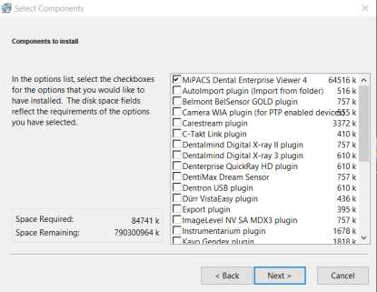

You must run the installer on every workstation on the network. Often, different components are installed on different workstations depending on the equipment in the treatment room. In large organizations, it is possible to automate the workstation installation. Contact Medicor Imaging for more information.

It is possible to re-run the installer at a later time to add components that were not selected previously. All components that are selected in the list will overwrite previously installed components. This way, it is possible to reinstall the application or components if the installation has become damaged. The installer will not uninstall components if they are deselected. The application and all components can be uninstalled from **Apps & features** in the **Settings** window in Windows.

No hardware drivers or other third-party software that are needed to connect specific equipment is included in the MiPACS 4.0 installation package. You can download drivers and other software from the equipment manufacturer's website if those are not included with the equipment. Install drivers only with the correct version number according to the relevant plugin section in Appendix B: Component-Specific Instructions.

|  |  |
| --- | --- |
| icon | **Caution!**  Install only tested software configurations, and verify that the system works after installation! If components such as plugins or drivers have a different version than those listed in the installation instructions, the system or the component may not work, which may delay dental treatment. |

### Database Setup

The MiPACS Dental Viewer database consists of two parts: an SQL server database that stores patient information and image metadata and a directory structure in Windows that contains the image files belonging to each patient.

The SQL server database and image store typically reside on the same server for small- and medium-sized installations. In large organizations, it may be desirable for performance reasons to separate the server roles and place the image store on a Storage Area Network (SAN), possibly combined with clustering of database servers and/or storage servers.

In MiPACS Enterprise installations, redundant storage can be provided by a DICOM storage server. In such installations, additional redundancy can be obtained if the DICOM storage server cluster is physically separated from the MiPACS database servers.

|  |  |
| --- | --- |
| icon | **Caution!**  Setup database and network combinations that have been tested according to the installation instructions. If the image database connection is lost, dental treatment may be delayed. |

#### SQL Server Installation

The MiPACS database requires Microsoft SQL Server. It is available in different editions for large and small organizations and the SQL Server Express edition is available for download at no cost. See <https://www.microsoft.com/en-us/server-cloud/products/sql-server/> for more information.

Planning and configuration of a large SQL Server installation could be a complex task. Database administrators may contact Medicor Imaging for assistance before deployment.

For small- and medium-sized dental practices, it is possible that SQL Server Express may suffice. The following sections provide a short description of SQL Server Express setup for a small- or medium-sized installation. The description illustrates the general concepts, but SQL Server installation is otherwise beyond the scope of this document. It is the responsibility of the installer or database administrator to install and configure the database server according to the needs of the organization.

#### SQL Server Express Installation and Setup

Download and run the SQL Server Express with Tools installer. This version contains SQL Server Management Studio, which may be needed for maintenance tasks such as restoring backups.

#### Create Server Instance

The installer will ask for the instance name to set up:

* **Default instance** – “MSSQLSERVER,” which will allow connections using just the server name. You can use the default instance if this is the only instance on the server.
* **Named instance** – The default named instance is “SQLExpress.” If the server already runs existing SQL Server instances, such as for a patient management system database, we recommend that you create a separate instance for MiPACS by changing the named instance to “MIPACS” or something similar.

#### Server Configuration

Change the setting for **Authentication mode** to **mixed mode** to allow Windows authentication as well as enabling the administrative user “sa” login. Choose a password for the “sa” user.

**Important**: Write down the selected "sa" password, and store it in a secure location. The password will be needed later to create and restore database backups.

#### Accept Incoming Connections

This step may not be needed for a single-user installation where MiPACS and the SQL Server database are stored on the same computer.

In SQL Server Configuration Manager,configure the server to accept incoming connections. Select **Network Configuration** and **Protocols**. Enable the options **TCP/IP** and **Named Pipes**.

Restart the SQL Server service. Make sure that it starts and that the SQL Server Browser is running.

Incoming client connections may be blocked by the Windows firewall or by a third-party security application. Make sure that the necessary ports are open in the firewalls.

If database access uses Windows authentication, you must properly configure all MiPACS user accounts with read and write access rights to the SQL Server. This is easier to maintain in a Windows domain environment.

#### Image Store Setup

The image store is a shared directory on a server. The image store server can be the same server as the one running SQL Server or a different server on the network. The image files can be located on the workstation itself for single-user systems (in which case, there is no need to share the folder on the network).

MiPACS will create the directory structure in the share when the database is created. First, create the share, and set the user access rights. All MiPACS users (domain users or local Windows accounts) need both read and write access rights to the image store directory structure at the operating system level.

You should make the image store path available to all clients through a UNC path (in a **\**\SERVER_NAME\IMAGE_STORE_SHARE format). We do not recommend that you use a mapped drive in the path (such as X:\ImageStore). Such mappings are user-specific and may not be available when the application is run as an administrator.

The image store path is stored in the SQL database. If the SQL database is moved to a new server, or if a backup is restored in a new environment, you must change the image store path to the new location.

|  |  |
| --- | --- |
| icon | **Caution!**  Configure the network settings properly according to the installation instructions. If the system or a component does not work, dental treatment may be delayed. |

#### Database Creation

To create a new database, start MiPACS on a workstation. On the **System** menu, select **Create new database**. Under **Server name**, enter one of the following:

* If a named SQL Server instance was installed, enter the name of the server and instance in a SERVER_NAME\INSTANCE_NAME format.
* If a default SQL Server instance was installed, enter only the server name.

Enter a name for the new database, such as **MiPACS_Viewer**. Select the path to the **image store** share configured previously (**\**\SERVER_NAME\IMAGE_STORE_SHARE). Click **OK** to create the new database.

An SQL Server login dialog box appears. As the user name, enter **sa**, and enter the password that was selected during the SQL Server installation. You can also select Windows authentication, for instance, in a Windows domain environment with domain users properly configured with access rights to the SQL Server. Click **OK**.

#### Database Selection

To connect to an existing database, for example, when adding a new workstation to the network, first start MiPACS on an existing workstation, and then select **Database information** on the **System** menu. This will show the existing **server instance name** and the **image store path**. Note the information and use it on the new workstation.

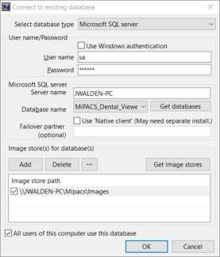

On the **System** menu, select **Connect to existing database**. Enter the SQL Server authentication parameters. Under **Server name**, enter the name of the SQL Server instance where the MiPACS database is stored. If the client can connect to the server, a list of databases on the server appears in the list. Select the correct database in the list. The image store path stored in the database appears and can be changed, such as for migrating or restoring a database to a new environment. Click **OK** to connect to the existing database.

If the SQL Server or the image store cannot be reached from the new workstation, check the network settings, and verify that any firewall software in the server and/or the workstation is configured to allow connections.

|  |  |
| --- | --- |
| icon | **Caution!**  Configure the database settings properly according to the installation instructions. If the system or a component does not work, dental treatment may be delayed. |

#### 

#### Database Backup

|  |  |
| --- | --- |
| icon | **Caution!**  Configure a system that creates regular backups of the SQL database and image store, and verify that the backup system works. If the image database is lost, dental treatment may be delayed. |

It is essential to create regular backups of the SQL Server database as well as the image store files. You must perform backups daily or even more frequently and transfer them to an off-site location. Third-party backup software is commercially available and is capable of backing up a SQL Server database as well as any other data stored at the practice, such as the patient management system database. In some editions of SQL Server, it is also possible to schedule automatic backups using the SQL Server agent in Management Studio.

If such options are not available, a simple SQL Server backup script is included with the MiPACS installation. After manual configuration, you can use command-line tools to create a SQL database backup to a file that can then be copied to the backup media by any file-copy tool.

The **sqlbackup** script is located in the application folder in the Program Files directory. Configure the script according to instructions in section B22. SQL Backup Script, and then schedule it to run regularly with Windows Task Scheduler.

The script will create a SQL backup file (such as **MiPACSDB.bak**) in the desired folder, which is **C:\MiPACSBackup** on the server by default. The whole MiPACS patient database is then backed up or moved to a new server by copying the .bak file and the entire contents, including subfolders, of the image store folder.

#### Move or Restore Database

If the patient database is destroyed or corrupted, possibly due to a database server crash or a fire, it may be necessary to restore the most recent existing backup.

When performing a planned migration to a new server, start by creating a fresh backup according to the aforementioned instructions. The backup consists of the following:

* A .bak file (named MiPACSDB.bak or something similar) that contains the backup of the SQL database
* The entire image store directory structure, including files and subfolders.

Install a new SQL Server, and set up a new image store share according to the aforementioned instructions. Next, use Management Studio to restore the .bak file, and copy all the image store contents to the new location. Make sure that all users have read and write access rights in the new image store.

Launch MiPACS on a workstation. Select **Connect to existing database** on the **System** menu, select the database on the new server, and then click **OK** to verify the connection. Select **Connect to existing database** on the **System** menu again, change the image store path in the restored database to the correct path of the new image store location (do not click **Add** to create a second image store folder), and then click **OK**.

Test the restored or migrated system by accessing patients and old images on all workstations. Verify that image capture still works.

### Application Setup

|  |  |
| --- | --- |
| icon | **Caution!**  Application settings must be set carefully according to the instructions and to the current clinical environment. If the settings are wrong, there is a risk of misdiagnosis or malpractice. |

Most of the settings in the main MiPACS Dental Viewer application are accessed from the **Preferences** dialog box, which are accessed from the **System** menu. The dialog box consists of a number of tabs with different groups of settings. The settings are sometimes stored in the common database and thus affect all users and all computers. Other settings are stored in the registry and affect either the local computer or the currently logged in user.

In order to save some settings after changing them in the Preferences, Windows administrator rights are needed. If User Access Control (UAC) is turned on, you must start the application by right-clicking the MiPACS 4.0 icon and then selecting **Run as administrator**. When a user opens Preferences, a warning message alerts the user if settings cannot be saved because the user lacks administrator rights.

The following sections provide a short description of the tabs in the Preferences dialog box. Some of the settings are described in greater detail in the following sections. Only the first tabs (**User** and **License**) are available to end-users. To access the other tabs, you must first click **Advanced**, and then confirm the warning message.

#### User

These settings are intended for end-users and control the language and user-interface appearance for the current user. There is also an option to reset the menus and toolbars if they become corrupted.

#### License

On this tab, you can view and manage license keys stored in the database. See Chapter 8 in the “Instructions of Use” for more information.

#### General

You can configure referrer settings that affect how the system prompts for a referrer during capture. A referreris a person who requests images and who is later responsible for approving them.

#### Integration

These settings control the connection to some patient management systems (PMS). For instance, it is possible to disable the built-in patient edit and search functions when a PMS is used.

#### Display

Settings that control the rendering of images on the computer screen. Use these settings with caution, and remember that monitor calibration may be affected (Chapter 10 in “Instructions of Use”).

#### Capture

On this tab, there are settings for image enhancement and other processing, such as mirroring, which will be applied on images after they are captured with a specific plugin but before they appear in MiPACS. You can apply individual processing to different image sources. Do not use additional image enhancement here if it is already applied in the plugin settings. See Chapter 9 in “Instructions of Use” for more information.

#### Security

These settings control the login method, user access rights, access to DICOM storage servers and Modality worklist servers.

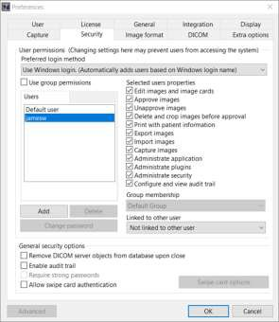

The settings on the **Security** tab control access rights within MiPACS for different users or groups of users. By default, the login name in Windows is used for logging in. This can be changed to AD login for Windows domains or Application login for peer-to-peer networks. If these settings are used, there is no need to log out of Windows to change users, and MiPACS presents a login prompt when the application is launched. In this setup, you can also configure MiPACS to use swipe cards for logging in and approving images.

You can modify user access rights for the **Default user**, which affects new users that are added, or you can modify rights separately for each existing user or a group of users. Select a user in the left list, and then select the checkboxes to the right to control access to various features.

The installer or administrator that changes permissions for other users must have the “Administrate security” right. However, once a user with this permission has been added, you should remove the “Administrate security” right from the Default user and any ordinary users.

The user permissions are dependent on the workflow and roles of the users and should be decided together with a clinic manager or responsible dentist. See the “Instructions for Use”for more information about how user permissions affect the functionality of the application. For instance, an assistant that captures images but is not allowed to diagnose can have permission to edit, capture and import images; and a dentist can have the same permissions and permission to approve and export imagesand possibly to delete and crop. The “Unapprove images” right should be reserved for a clinic manager or system administrator and possibly only activated on a temporary basis. This is especially important in MiPACS Enterprise installations. Unapproving approved images is not a routine task and should only be done if the approval was made by mistake.

Installers and IT technicians need to have the “Administrate application” and “Administrate plugins” rights to change the settings in Preferences and plugin settings.

|  |  |
| --- | --- |
| icon | **Caution!**  Configure the security settings properly according to the installation instructions. If the system or a component does not work, dental treatment may be delayed. |

#### Image Format

These settings control the image file format in the MiPACS database. The choice of file compression affects the size of the image files and the database but can also decrease the image quality. This setting affects all users and should be changed with caution and only if necessary.

#### DICOM

(For MiPACS Enterprise Only)

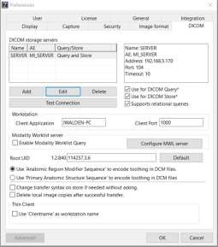

With the settings on the **DICOM** tab, you can configure a client to connect to one or several **DICOM storage servers**. Configure each server by entering its AE title, IP address, and port number, which you can obtain from the DICOM server administrator. When configuring the connection, make sure that the right network adapter on the client is selected if there are several adapters installed.

Multiple servers may be selected for DICOM Query and are then available for searching patients, but only one may be used for storage. In some environments, we recommend that you configure all clients with DICOM Query only (no DICOM Store) and instead setup asynchronous batch transfer of approved images from the MiPACS database server to the DICOM storage server as a scheduled job performed daily or weekly. Unapproved images may be approved and transferred at a later stage with the List unapproved seriestool.

To access a DICOM server, the client must be configured with a unique **Client Application** (AE) title and **Client Port** number. The same information needs to be entered into the DICOM server by the server administrator. After configuring the client AE and port, you can test the connection to each storage server by selecting the server in the list and then clicking **Test Connection**. On this tab, you can also enable **Modality Worklist Query** and configure the MWL server settings.

|  |  |
| --- | --- |
| icon | **Caution!**  Store all images in the MiPACS database as well as in the DICOM server for redundancy. If historic images or data are lost, there is a risk of decreased diagnostic capability. |

### License Management

After MiPACS 4.0 is purchased, an installation license is created for a certain number of workstations. This is controlled with a license key that is entered on one of the workstations and stored in the database. When the license is renewed or if the number of workstations needs to be increased, a new key is distributed. A list of the license keys stored in the database and their type and expiry date appears on the **License** tab in the **Preferences** dialog box.

The license key is a text file that contains the name of the practice and a code string. When a new license key is distributed by email, double-click the license file to import it into MiPACS. If the license file is unavailable, on the **License** tab in the **Preferences** dialog box, enter the code string exactly as shown. If it fails, be aware that some letters and digits may look similar (such as 1/I/l and 0/O).

### Plugin Setup

|  |  |
| --- | --- |
| icon | **Caution!**  Configure the imaging hardware settings properly according to the installation instructions. If the system or a component does not work, dental treatment may be delayed. |

Run or re-run the package installer to select and install the plugins needed to connect the desired equipment to the workstation after determining that the equipment model is supported and the system requirements fulfilled (refer to the relevant plugin section in Appendix B: Component-Specific Instructions.

When a plugin is installed, it appears in MiPACS as an extra toolbar. On the **Tools** menu, select **Plugin options** to enable or disable selected plugins. The settings for each plugin can also be accessed from the **Tools** menu. This requires the user to have the “Administrate plugins”security right (see Chapter 7 in “Instructions of Use”). In the settings dialog for each plugin, there are parameters that may need to be adjusted.

#### Video Plugin

For the Video plugin, the intraoral camera model or connection method is selected, possibly with additional parameters according to the plugin in section B20. Video and the camera manufacturer’s instructions. If the camera buttons do not work, you may also configure a foot switch in the Video plugin.

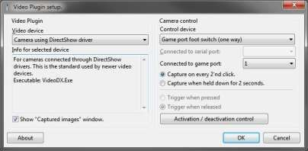

#### Camera Plugins

For cameras, we recommend that you set up auto-selection of a certain template when images are captured so that photographs are not placed in an X-ray template. On the **Capture** tab of the **Preferences** dialog box, select the plugin used for camera capture, select the **Use auto-selected template** checkbox, and then select a suitable template, such as PA5 or PA9.

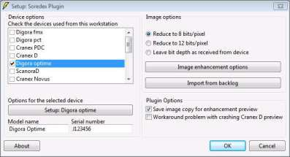

#### X-ray Plugins

For several X-ray plugins, the devices connected to the workstation can be specified, sometimes with additional settings for each device. Review and adjust these settings according to the plugin instructions in Appendix B: Component-Specific Instructions and the instructions from the device manufacturer.

Some X-ray devices need to be activated before capture. Once a plugin is installed, on the **Capture** tab of the **Preference**s dialog box, you can configure automatic activation of a specific device when a patient record is opened.

The X-ray plugins also have image enhancement options. Adjust these accordingly. For these plugins, there is also an option to reduce the image quality an image is stored in MiPACS.

Image enhancement can be applied in several steps of the capture chain:

1. By the driver – Some drivers use image enhancement filters that sometimes cannot be disabled.
2. By the plugin – On the **Capture** tab of the **Preferences** dialog box, image enhancement and similar options can be configured.
3. By the user – The user may add image enhancement during analysis with the tools in the program.

Some enhancements, such as noise reduction and edge enhancement, are destructive and can degrade the image quality, especially if they are applied repeatedly. We therefore recommend that image enhancement be applied in only one of the steps in the capture chain, and having images enhanced by the plugin is preferred.

Reduction of image quality should be applied after image enhancements for best results. If users prefer to perform extensive image enhancement in the program, disable reduction of image quality in the plugin settings. Images will then consume considerably more storage space.

|  |  |
| --- | --- |
| icon | **Caution!**  Verify that the image acquisition chain works after installation! If the system or a component does not work, dental treatment may be delayed. |

#### Image Enhancement

|  |  |
| --- | --- |
| icon | **Warning!**  Adjust image enhancement settings carefully according to the instructions, and have a dentist verify them before they are put into clinical use. Incorrect settings could lead to inferior image quality and misdiagnosis or malpractice. |

Each X-ray plugin has individual image enhancement settings which can be applied to all new images that are captured with the connected device. Some plugins support more than one type of device, such as sensors and scanners, and may then have separate enhancement settings for each device.

In the image enhancement dialog, change the settings, and then click **Update preview** to see the result. Compare the enhanced image to the raw image. Test different settings until the image quality is sufficient to perform accurate diagnoses.

**Important**: This step requires the approval of the dentist!

To start over from the default settings, click **Defaults**. Click **OK** to save the settings or **Cancel** to close without saving. Resize or maximize the window to get larger images. Click an image to switch between displaying the full image or a zoomed-in view. Press the plus sign key (+) to zoom in and the minus sign key (-) to zoom out.

#### Histogram Adjustments

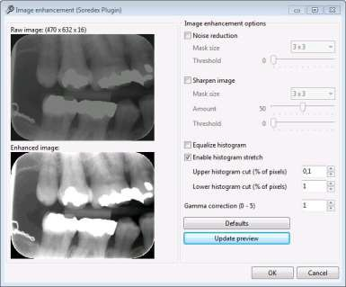

Often, images are too bright and have poor contrast. You can improve this by reducing the **Gamma correction** value to approximately 0,5 to 0,8. You can brighten dark images by increasing the gamma value above 1. Gamma = 1 corresponds to an unchanged image.

As a final step after calibrating the X-ray chain, you can enable **Histogram stretch** to obtain optimal contrast. Adjust the limits for **Upper histogram cut** and **Lower histogram cut** to stretch the histogram. 0% to 2% is usually enough. The **Equalize histogram** option offers even more contrast but can make the image look distorted. Use this option with caution.

#### Noise Reduction

Sometimes you can reduce the noise in an image by selecting **Noise reduction**, which will apply a median filter on the image. You can adjust the degree of noise reduction by using the **Mask size**. If the smallest mask size (3x3) does not remove all noise, try a slightly larger size, such 5x5 or 7x7. Note that overly large masks are destructive for the image details. You can set a small threshold value with the **Threshold** slider to reduce unwanted side effects of the noise reduction. Use this filter with caution since small details in the image may be lost, especially with large mask sizes.

#### Sharpening

The **Sharpen image** option can enhance the perceived sharpness of the images. An “unsharp mask” filter will then be applied, and the three parameters may need adjusting to get a good result. The degree of sharpness is set by the **Amount**. 20-50 is often enough. You can also increase the sharpness by selecting a larger **Mask size**. The best result is obtained with a small mask size and a moderate amount. Too much sharpness will introduce artifacts in the image. Sharpening will also amplify noise in the image; therefore, noise reduction is often used in conjunction with sharpening. In addition, you can raise the **Threshold** value slightly for the sharpening filter to further reduce the noise effect. A threshold of 2-10 usually provides sufficient noise reduction.

#### Important Note about Destructive Image Operations

Please note that the image enhancement functions in the plugin settings perform irreversible operations on all captured images. The filters distort information and may even add misleading effects that were not present in the original image, and there is no way to recover the original image after permanent image enhancement has been applied. Use the image enhancement filters with caution and realize that an image with good appearance may not be optimal for diagnostic purposes.

### X-ray Imaging System Calibration

|  |  |
| --- | --- |
| icon | **Warning!**  You must properly calibrate the X-ray imaging system before it is put into clinical use. Inferior image quality could cause misdiagnosis or malpractice. |

You must calibrate every X-ray imaging system before it is used for diagnostic purposes. You must also check the imaging system regularly to verify that it does not deteriorate, due to aging of the X-ray source or due to inadvertently changed settings.

The term “X-ray imaging system” here includes the whole chain of components, each of which may affect image quality:

* The X-ray source.
* Imaging devices such as sensors and scanners.
* Drivers, which sometimes contain image enhancement algorithms.
* MiPACS plugins with image enhancement filters.
* The MiPACS application and other imaging software.
* The computer monitor, where the dentist interprets the result.

Before you calibrate the X-ray imaging system, it is important that the X-ray source is in good condition and functioning properly. The performance of the X-ray source must be verified by regular dose measurements. This should be performed by the distributor of the X-ray source.

If a new X-ray imaging system is installed or any of the components in the system are replaced, you must calibrate the imaging system. The calibration includes adjusting the exposure time of the X-ray source to obtain optimal image quality from sensors and phosphor plates while minimizing the X-ray dose to patients. In addition, this includes configuring the image enhancement settings in MiPACS and/or hardware drivers and calibrating the computer monitor for correct rendering of X-ray images.

Refer to the following checklist for calibrating the X-ray imaging system after new hardware is installed or some part of the system is replaced:

1. Install the X-ray sensor or phosphor plate scanner according to the manufacturer’s instructions.
2. Follow the plugin installation instruction in the relevant section of Appendix B: Component-Specific Instructions.
3. Calibrate the monitor as described in the next section.
4. Go to **System > Preferences > Capture**. Select the correct plugin under **Select source**. Turn off all image enhancements; deselect all options in the list, and disable gamma correction (set gamma = 1). Click **OK** to save the settings.
5. Open the plugin settings from the **Tools** menu. Click **Image enhancement options**, and disable all settings explained previously. If the **Save image copy for enhancement preview** option is available in the plugin settings, make sure it is turned on.
6. Sometimes there are also settings in the driver software that gets installed with the device that may affect the image. Check the manufacturer's instructions on how to calibrate and optimize such settings before moving on. Disable image enhancement in the driver if possible.
7. Capture a test image under realistic clinical conditions. Use an imaging phantom or ideally real teeth, and expose an image using the recommended X-ray exposure time according to the device manufacturer's instruction.
8. In MiPACS, open the Histogram tool, and check that the grayscale content of the image is within the boundaries of the histogram. Optimally, the main peak should be centered in the range, but sometimes the dynamic range of the device is so wide that the content is in a narrower part. If the grayscale content looks like it is partly outside the histogram range, adjust the X-ray exposure time accordingly and capture a new image. Repeat these steps until a good exposure is made. Write down the exposure time, voltage, and other parameters that are set on the X-ray source, and use them as the standard for future captures.
9. Go to the plugin settings again, and turn on the image enhancements(see Chapter 9 in “Instructions of Use”). In the image enhancement dialog box there is now a preview of the last image captured. Use it to adjust the settings for optimal image quality. It is the responsibility of the dentist to approve the final image quality.
10. When done, click **OK** in the image enhancement dialog box, and click **OK** in the plugin setup dialog box to save all settings.
11. Restart the computer, and capture another image to confirm that all settings were saved and that the image quality is still good.
12. The image quality shall be approved for diagnostic use by the dentist. Use the approval form in Appendix C: Installation Approval Form.

**Note**: Image enhancement settings may cause loss of information and/or introduction of artifacts in the image. This could decrease the diagnostic value of the image. Use the settings with caution, and do not turn on settings unless the dentist determines that they aid in accurate diagnosis.

#### Monitor Calibration

|  |  |
| --- | --- |
| icon | **Warning!**  You must properly calibrate the computer monitor before it is put into clinical use. Inferior image quality could cause misdiagnosis or malpractice. |

It is important to calibrate the computer monitor to make sure that X-ray images are displayed accurately. With incorrect settings, important clinical information may be lost in the darker or lighter parts of the image. Incorrect settings may also cause distorted image proportions.

Also consider the lighting conditions of the room, and the fact that the monitor orientation with respect to other light sources and the viewing angle may affect the perception of images on the monitor.

It is very important to use a high-quality computer monitor. We strongly recommend that you use a monitor designed to display medical grayscale images (sometimes called a DICOM monitor). Sometimes such monitors are factory-calibrated, and the settings cannot be changed; in other cases, special software and/or hardware must be used for calibrating the monitor. Refer to the manufacturer's instructions. The computer's graphics adapter must be installed with the proper driver and set to the correct resolution based on the monitor specification. Also, check that it is set to at least 24-bit color depth.

MiPACS’s Monitor Calibration tool (which you can access from the **System** menu) can facilitate the calibration and regular checkup of the monitor. It displays a test image for you to use when adjusting the display for optimum image quality. Each monitor calibration that you perform is logged with the date and time, workstation, the user who performed the calibration, and any comment made. By default, the Monitor Calibration tool shows a list of all monitor calibrations that were made at the current workstation. Selecting the **Show calibrations for all workstations** checkbox allows you to see calibrations that were performed at all workstations that are connected to the same database.

Click **Perform new calibration** to show the test image.

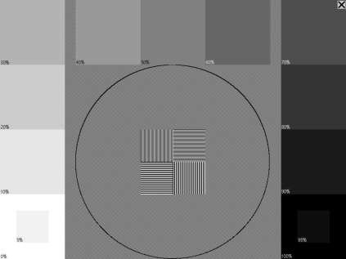

Adjust the brightness, contrast, and other settings of the monitor so that it is possible to distinguish the fields inside the boxes at the bottom left and right that are marked **5%** and **95%**. Check that all shades of gray are correctly displayed.

Verify that the proportions are correct. Boxes with gray shades should be squares, and there should be a circle in the middle. Use a ruler to measure that the height and width of the circle are equal. If the proportions are not correct, the resolution of the monitor or graphics adapter is not configured properly.

#### Consistency Check

To maintain the calibrated state of the X-ray imaging system, you must use MiPACS’s Consistency check tool (which you can access from the **System** menu) to perform and document regular consistency tests.

This tool opens a record, similar to a patient record, with the name “Consistency check.” You can display and store images as usual. Perform the consistency check as a fixed routine with certain periodicity, each time with the same X-ray exposure time, imaging phantom, and distance between the phantom and X-ray source. Check that the image quality has not deteriorated since the last time. If it has, it means that some component of the capture chain has changed for the worse.

When you capture images during a consistency check, the average grayscale value of the image is automatically saved as an image comment. This value normally appears in the lower-right corner on the status bar when you select the image. Also, you can use the Color Probetool (**Image** > **Color/Gray-levels**) to check the grayscale in various parts of the test image. Enter the measurements as comments.

Please note that there is only one consistency check record in the database, so you should save each image series with a unique name for each workstation (such as the name of the treatment room).

When you perform the consistency check, it is important that all image enhancement filters that can hide any X-ray imaging system deterioration are turned off wherever possible in order to get an accurate picture of the state of the capture chain. Some image enhancement functions can compensate for bad exposures, such as Histogram stretch, so you must disable them during the consistency check.

Sample routine for consistency check:

1. Go to **System** > **Consistency check**.
2. Go to **System** > **Preferences** > **Capture**. Select the correct plugin under **Select source**. Turn off all image enhancements, deselect all the options in the list, and disable gamma correction (set gamma = 1). Click **OK** to save the settings.
3. Open the plugin settings from the **Tools** menu. Click **Image enhancement options**, and disable all settings explained previously.
4. Sometimes there are also settings in the driver software that get installed with the device that may affect the image. If such settings are enabled, make sure they are set equally at each consistency check session. At least turn off functions that would hide changes in exposure like histogram stretching or automatic grayscale leveling.
5. Capture a few images with different exposure times using the X-ray phantom.
6. Check the average grayscale value (in the status bar): measure the grayscale in different parts of the image with the Color Probe tool, and check the histogram. Compare this with previous checks made under the same circumstances, and note any differences.
7. Restore all settings to the way they were before the consistency check.
8. If you observe deterioration in the system, troubleshoot it to determine the cause and take corrective action.

### Patient Management System Integration

Patient management systems (PMS) are generally adapted to work with MiPACS by the PMS manufacturer. Once a PMS is installed, configuration of the PMS might be needed to connect it to MiPACS so that it is possible to open a patient in MiPACS (for example, by clicking a button in the PMS). This is usually performed by the distributor or installer of the PMS.

If there is no integration to MiPACS that is built into the PMS, a couple of tools are supplied that you can use to set up a connection between the PMS and MiPACS:

* **Patient Selector** – A configurable tool that you can set up to read patient information from the window of the PMS. Documentation for this tool appears in section B23. Patient Selector.
* **Command line link** – An interface to MiPACS. Documentation for this tool appears in section B24. Command Line Link.

### Templates

|  |  |
| --- | --- |
| icon | **Warning!**  Create user-defined templates carefully according to the instructions, and a dentist must verify them before they are put into clinical use. If there is an error in a template, there is a risk of misdiagnosis or malpractice. |

Use templates to arrange images for diagnosis and to assign anatomic information to images. In addition to the built-in templates in MiPACS, you can create new templates from scratch or by modifying existing templates. Also, you can export and import files containing templates. You cannot delete the built-in templates, but you can hide them from the menu.

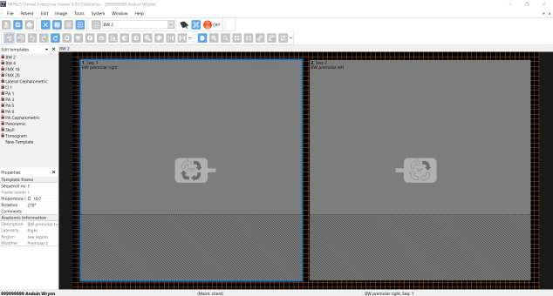

Do the following:

1. On the **Window** menu, select **Edit templates**.
2. Either select an existing template in the list pane and save it with a new name using **Save As**, or start with an empty template and add frames using **Tools** > **Add image frame to template**. Arrange the frames, and adjust their sizes by dragging the corners. To view gridlines, select **Show/hide grid** on the **Tools** menu.
3. Under **Properties** in the list pane, enter the **Sequence number**, **Frame number**, **Proportions**, and **Rotation** correctly. The sequence number controls the order in which captured images are placed into the frames. Proportions control the aspect ratio of images by masking off a section of the square frame.
4. Also, enter correct **Anatomic information** for each frame. The **Laterality**, **Region**, and **Modifier** information will be filled in according to the selected **Anatomic Description**.
5. Click **Save** to save the new template.
6. Go back to **Properties**, and give the template a type, such as **Intraoral** or **Secondary Capture**.

**Important**: All template settings must be verified by the dentist before clinical use.

1. After a dentist approves the template, click **Save** to save the new template in the database and make it available to all workstations.

### Upgrading from a Previous MiPACS Version

It is not possible to install MiPACS 4.0 if an older version, such as MiPACS 3.1, is already installed on the computer. You must first uninstall MiPACS 3.1 for the MiPACS 4.0 installer to run.

Before uninstalling an older version, we recommend that you write down important settings in the old system, especially database settings and plugin settings, such as image enhancements. All settings are reset to default values when you install MiPACS 4.0.

A major part of equipment, such as sensors and cameras, currently in use by MiPACS 3.1 users is supported with the set of plugins included with MiPACS 4.0. In future releases, support for additional equipment will be added as soon as possible. However, some legacy hardware that was supported in MiPACS 3.1 may not be supported in MiPACS 4.0 (this is determined by the number of users and the system requirements of the legacy equipment). For instance, the drivers for some older sensors only work on Windows XP, which is a deprecated operating system. In such cases, it is necessary to replace the hardware with a modern alternative before you upgrade to MiPACS 4.0.

#### Connecting 3.1 and 4.0 Workstations to the Same Database

In some cases, it may be necessary to connect both MiPACS 3.1 and MiPACS 4.0 workstations to the same database. Examples of such situations include:

* Legacy hardware is still in use and working with MiPACS 3.1 but not supported by 4.0.
* A gradual upgrade of a large system where both versions need to co-exist until all workstations have been upgraded.

In order to make this work, both a MiPACS 3.1 and a MiPACS 4.0 license must be stored in the common database. Both licenses must be issued to the same customer name. Add the MiPACS 3.1 license from a 3.1 workstation and the MiPACS 4.0 license from a 4.0 station after you connect it to the database.

### Problem Solving/Troubleshooting

If there are any problems with MiPACS or any attached equipment, please verify that the installation instructions in this document and all instructions from the manufacturers of the attached equipment have been followed.

Medicor Imaging manufactures only the image management system and the included software components, such as plugins. Problems with third-party hardware or software that are attached to MiPACS (such as sensors, cameras, drivers, or patient management systems) are beyond the scope of Medicor Imaging. In such cases, contact the distributor or manufacturer of the hardware or software for assistance.

If MiPACS has lost the connection to the network or server, a network errorappears until the connection is restored. Such errors do not generally indicate a problem within the MiPACS software.

If a software erroroccurs in MiPACS, a warning message appears, and the error is logged to a file. Please report any software errors to Medicor Imaging as soon as possible. The System Information utility (which you can access from the **Help** menu) displays the configuration of the system. Also, the utility allows the error log to be inspected and the report to be transmitted to Medicor Imaging for collection of user statistics and troubleshooting.

If there are any other problems that you cannot solve using the information in this document, contact Medicor Imaging for assistance.

A few common problems and solutions appear in the following table.

| Problem | Cause | Solution |
| --- | --- | --- |
| Message “No access to network or database” appears on workstation. | Network cable is disconnected, or database server is unavailable. | Check the network connections of the  workstation. Check that the SQL  database server is available to the  client. |
| Message “Image store folder not available” appears on workstation. | Server hosting the image store folder or network connection is down. | Check that the server that hosts the MiPACS image store is available to the client. Check that the user has read and write access rights to the image store folder. |
| Message “There is only XX MB free disk space…” appears on workstation. | There is too little disk space remaining in the image store folder. | Free up disk space, or replace the disk with a larger capacity one. |
| Database server is non-responsive or backup system is not working. | The SQL Server transaction log  file has grown extremely large,  and the disk is full. The log is  deleted when a backup is performed, so this is a sign that backups are not working. | Perform a backup of the SQL Server  database. This will empty the log file. |
| Toolbars or menus are corrupted, or items are missing. | Menus were altered by user, or menu file has been damaged. | Go to P**references** > **User**, select the **Reset menu and toolbars** checkbox. Then, restart the application. |
| Message “NOT FOR CLINICAL USE” appears. | The configuration is corrupted, or invalid components are found. | Do not use the software! Completely uninstall MiPACS, and reinstall it from a verified installation package. |
| On-screen, an X appears in place of an image. Message about manipulated or missing image appears. | Image file is not found where expected, or file cannot be opened. | Verify that the image store folder is available to the user. Right-click the X image, and select **Image information**. Note the path. Open the path in a **File Explorer** window, and look for the file. If you find it, try to open it in the **Import images** dialog box to see if can be opened. Check that it has the correct name according to the path noted. If the file is missing, restore it from a backup. |
| X-ray image quality is consistently poor. | Uncalibrated X-ray image capture chain. | Calibrate the X-ray imaging system. |
| Unable to activate capture device, typically a sensor. Plugin status indicator stays red or switches back to red when activation is attempted. | Hardware or driver failure. | Restart computer and device control box, and check device cables and connection. Check hardware. If possible, try device on another workstation to verify that the device is not broken.  Reinstall drivers. For a USB device, try connecting without any USB hubs, other USB devices, and cable extenders. Try different USB ports. Make sure power saving features are turned off. |
| X-ray device is active but does not trigger on exposure. | X-ray exposure time set too low, incorrect configuration settings, or uncalibrated image capture chain. | Increase exposure time. Verify installation of drivers and configuration with manufacturers’ instructions and the plugin release notes. Calibrate the capture system. |
| Sensor spontaneously captures/imports images without exposure. Images are white, gray, or black. | Sensor is defective and may need to be replaced. | Turn off power to the computer and device. Try again on a test patient file.  If possible, try the device on a different station. If it still captures images spontaneously, replace the device. |

## MiPACS Business Continuity

If the EDR (Dentrix Enterprise) system is down (offline), you can make changes that will allow X-rays to be taken during the EDR system outage. And, once the EDR system is back online, you will be able to move the X-rays taken during the outage into the EDR system.

**Note:** We highly recommend that you call Medicor support for assistance with reconfiguring the MiPACS system when the EDR system is down.

**Medicor (MiPACS) Support**:

Phone: (704)-227-2629

Email: [support@medicorimaging.com](mailto:support@medicorimaging.com)

### EDR MIPACS Business Continuity Software Setup

Open the MiPACS Dental Enterprise Viewer, and make the following setting adjustments:

* **System** > **Preferences** > **Integration** tab – Clear the **PM System is active, disable edit of patient info** checkbox.

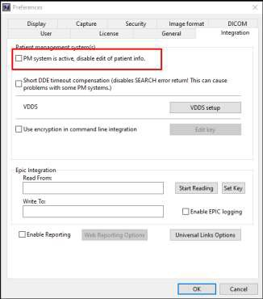

* **System** > **Preferences** > **General** tab > **Additional Preferences**:
  + **New Patient** – Select the **Display custom message on new patient window** checkbox, and then enter a custom message in the corresponding box.
  + **Find Patient** – Select the **Display custom message on find patient window** checkbox, and then enter a custom message in the corresponding box.

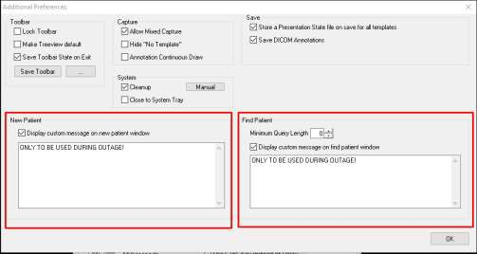

* **System** > **Preferences** > **General** tab – From the **ID number mask** list, select **Custom Mask**.

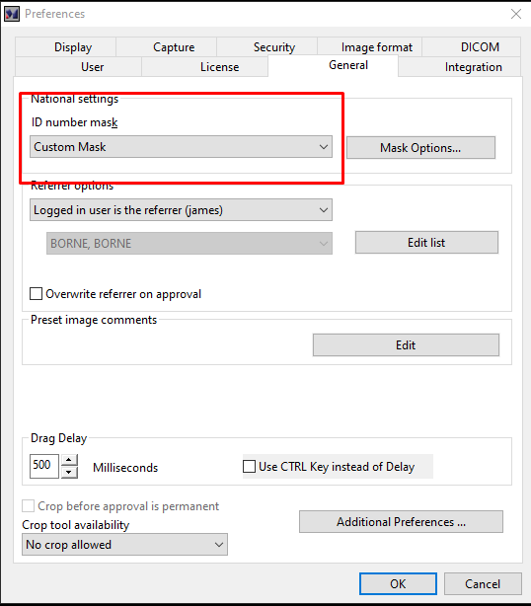

* **System** > **Preferences** > **General** tab > **Mask Options**:
  + **Prefix** – Type **TEMP_** in the box.
  + **Display message if patient records with prefix exist in database** – Select the **Display message when new or existing patient record is loaded** checkbox, and then enter a custom message in the corresponding box.

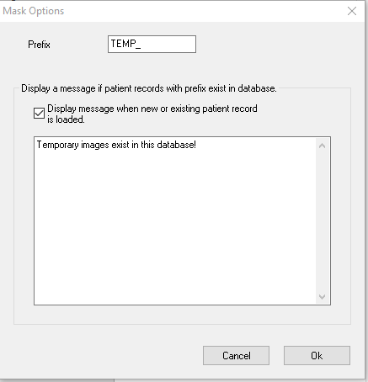

### EDR MIPACS Business Continuity User Setup

While the EDR system is down, do the following to capture and review images in MiPACS:

1. On the Windows **Start** menu, select **MiPACS Dental Enterprise Viewer** to open MiPACS in standalone mode.
2. Enter the generic application credentials to log in.
3. Do one of the following:
   * To open an existing patient’s record, do the following:
     1. On the **Patient** menu, select **Find patient**.

A pop-up message appears, reminding you that this functionality should be used only during the outage.

* + 1. Enter at least three letters to make the search button available, and then click the search button.
    2. Capture and review images as needed.

**Note**: When the EDR system is back up, the data will be synchronized in the background.

* + To create a new patient’s record, do the following:
    1. On the **Patient** menu, select **New patient**.

A pop-up message appears, reminding you that this functionality should be used only during the outage.

* + 1. Enter the patient’s information.

**Note**: A **Patient ID** with the prefix “TEMP_” is generated automatically and cannot be altered.

* + 1. Capture and review images as needed.

When the EDR system is back up, do the following:

1. With a patient selected in the Dentrix Enterprise Chart, click the **MiPACS** button to open MiPACS.
2. If any patient records were created during the outage, a pop-up message appears and informs you that patient records with temporary IDs exist and should be updated with the correct EDR Dentrix Enterprise IDs. Click **OK** to proceed, and then complete steps 3–5.

**Note**: While working in MiPACS, the following options are not available on the **Patient** menu:

* **New patient** – You cannot create a patient record.
* **Find patient** – You cannot search for a patient record.

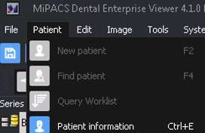

1. In the Patient Updater application, use the patient search to look up patients records with IDs that start with **TEMP_**. A list of all patient records that were created in MiPACS during the Dentrix Enterprise downtime appears.
2. For each of the temporary patient records, create a patient record in the Dentrix Enterprise Family File so you can get the patient ID.
3. In the Patient Updater application, for each of the temporary patient records, replace the patient ID in MiPACS with the patient ID from Dentrix Enterprise.

## Appendix B: Component-Specific Instructions

### B1. Autoimport

#### Description

You can use the Autoimport plugin to automatically import image files from a folder. You can configure a single folder and file name pattern for the plugin. All files matching the file pattern that get added to the folder will be imported. A local mapped network drive or UNC path is allowed.

This plugin is useful for importing images from other software or hardware (such as a digital camera or card reader) that stores images in a predefined folder.

#### Installation

1. Install MiPACS with the **MiPACS** and **Autoimport plugin** options selected.
2. In MiPACS, on the **Tools** menu, select **Auto Import plugin** to configure the import folder and file pattern.
3. When the configuration is tested and works, select the **Delete imported files** option to prevent the same images from being imported more than once.

#### User Instruction

Open a patient in MiPACS. Make sure that the Autoimport plugin is active. Copy an image file to the configured import folder. The image will be imported to the selected patient and deleted from the import folder (if so configured). The plugin will not import the same file more than once per session.

#### Known Issues

To avoid import attempts on unsupported file types, make sure you specify a file pattern that excludes the unwanted files (such as C:\Import\*.jpg). In this example, the Autoimport plugin will import all files in C:\Import\ that have a JPG extension and exclude all others (like thumbs.db).

#### Tested Configuration

MiPACS version: 4.0

OS: Windows 7, 8.1

### B2. Belmont BelSensor GOLD

#### Description

You can use the Belmont BelSensor GOLD plugin to acquire images from Belmont BelSensor GOLD intraoral X-ray sensors. You can connect up to 10 sensors to the same computer at the same time, but tests have only been made with one and two sensors. All connected sensors are automatically activated on startup.

#### Installation

1. Install MiPACS with the **MiPACS** and **Belmont BelSensor GOLD plugin** options selected.
2. Select a database, and add the license key.
3. Install the drivers that came with the sensor according to the manufacturer’s instructions.
4. Connect the sensor, and make sure that the drivers appear properly in Device Manager. A sensor usually appears under **Universal Serial Bus controllers**.
5. If your sensor came with a correction file, install it: in MiPACS, go to **Tools** > **Belmont BelSensor GOLD Plugin** > **Setup Belmont BelSensor GOLD Plugin**; then, click **Copy correction files**, and select the folder that contains the correction files (*.cor or *.cal).
6. Restart MiPACS, and test the system.

**Note**: For best performance, follow the instructions for calibrating your entire system. Refer to the installation instructions.

#### User Instruction

Open a patient in MiPACS. When the plugin status indicator shows ACTIVE, you can start capturing. The default settings make the plugin activate automatically as soon as a patient is selected. Make sure the status indicator shows ACTIVE before exposing the sensor.

#### Known Issues

No driver installer is included with the plugin like in the 3.1 version. Use the driver installer provided by the sensor manufacturer.

#### Tested Configuration

MiPACS version: 4.0

OS versions: Windows 7 32 & 64 bit, Windows 8.1 64 bit Sensor models: EV71JU213 & EV71JU215

Driver version: Philog SA, ver. 1.3.4.0 2010-02-04

### B3. Camera WIA

#### Description

You can use the Camera WIA plugin to automatically import images from a device supported by WIA (Windows Image Acquisition). Many scanners and digital cameras have WIA drivers that allow them to be used with this plugin. In particular, many DSLR cameras support WIA so that images can be captured and imported directly when a cable is attached between the camera and PC.

#### Installation

1. Install MiPACS with the **MiPACS** and **Camera WIA plugin** options selected.
2. In MiPACS, on the **Tools** menu, select **Camera WIA plugin** to configure the plugin.
3. Install the WIA device and its driver.

#### User Instruction

Open a patient in MiPACS. Connect or activate the WIA scanner/camera to import images from it. The plugin automatically detects connected devices and shows a button for it on the toolbar. The images will be imported to the selected patient and deleted from the import folder (if the plugin is configured to do so).

#### Known Issues

The **Show video preview** option only works on Windows Vista.

The **File format** option **Preserve received format as far as possible** is not applicable and will have no effect in Enterprise editions.

#### Tested Configuration

MiPACS version: 4.0

OS: Windows 7, 8.1

### B4. Carestream

#### Description

You can use the Carestream plugin to capture images from Carestream and Kodak dental imaging devices. This includes RVG intraoral sensors, CS phosphor plate scanners, panoramic and cephalometric devices, and intraoral cameras.

#### Installation

1. Install and configure your Carestream devices and their drivers according to the manufacturer’s instructions. You do not have to install the DIS imaging software.
2. Install MiPACS with the **MiPACS** and **Carestream plugin** options selected.
3. In MiPACS, go to **Tools** > **Carestream plugin** > **Setup Carestream plugin** to configure the plugin. The detected Carestream devices are listed. Select the ones that you want to use from the application’s toolbar.
4. Open a patient in MiPACS. Activate the Carestream plugin by clicking the button on the toolbar for your device. Then, capture an image to test the system.

**Note**: For best performance, follow the instructions for calibrating your entire system. Refer to the installation instructions.

#### User Instruction

Open a patient in MiPACS. Activate the Carestream plugin by clicking the button on the toolbar for your device. A dialog box appears. According to the manufacturer’s instructions, capture images for the selected patient.

#### Known Issues

Some devices in the list of devices for the plugin may not have the expected names. For example, the CS 7600 scanner may appear as **Stella**.

#### Tested Configuration

MiPACS version: 4.0

CS Acquisition DLL: 2.1.79.2, 2.1.80.0

Hardware: CS 7600, RVG 6000, RVG 6100

OS: Windows 7 32 bit, 8.1 64 bit

### B5. C-Takt Link

#### Description

You can use the C-Takt Link plugin to export images, series, and image cards to the C-Takt Link communications system. The C-Takt Link client application version 1.82 or later must be installed on the computer.

#### Installation

1. Install MiPACS with the **MiPACS** and **C-Takt Link plugin** options selected.
2. Install and configure the C-Takt Link client application.
3. In MiPACS, go to **Tools** > **C-Takt Link Plugin** > **Setup C-Takt Link Plugin**. Configure the plugin to suit your preferences.
4. Open a patient, select either a whole series/image card in the list or some images on a series/image card, and then click the **C-Takt Link plugin** button to test the system.

#### User Instruction

Open a patient in MiPACS, select either a whole series/image card in the list or some images on a series/image card. Click the **C-Takt Link plugin** button to add them to a new case in C-Takt Link. C-Takt Link opens. Enter your user credentials. Accept the data exported when prompted to do use. Use the icon with a plus sign (+) to add the images to an already open case in C-Takt Link. Selecting individual images in MiPACS will only export the selected images to C- Takt Link. Selecting a series or image card in the list will include all its images and the layout.

Only approved images are exported.

#### Known Issues

#561 – Using the plugin with C-Takt 2.0, 2.0.1 or 2.0.2 causes double and/or accumulated imports. This does not happen in 1.82. C-Takt/Unident has been able to repeat this and will fix it in a future release. In the 2.0.3 beta, it works.

#### Tested Configuration

MiPACS version: 4.0

C-Takt link versions: 2.0.2, 2.0.3 beta

OS: Windows 8.1

### B6. Dentalmind Digital X-ray II

#### Description

You can use the Dentalmind Digital X-Ray II plugin to acquire images from Dentalmind Digital X-Ray II intraoral X-ray sensors. It is possible to connect up to 10 sensors to the same computer at the same time, but tests have only been made with one and two sensors. All connected sensors are automatically activated on startup.

#### Installation

1. Install MiPACS with the **MiPACS** and **Dentalmind Digital X-Ray II plugin** options selected.
2. Select a database, and add the license key.
3. Install the drivers that came with your sensor according to the manufacturer’s instructions.
4. Connect the sensor, and make sure that the drivers appear properly in Device Manager. A sensor usually appears under **Universal Serial Bus controllers**.
5. If your sensor came with a correction file, install it: in MiPACS, go to **Tools** > **Dentalmind Digital X-Ray II Plugin** > **Setup Dentalmind Digital X-Ray II Plugin**; then, click **Copy correction files**, and select the folder that contains the correction files (*.cor or *.cal).
6. Restart MiPACS, and test the system.

**Note**: For best performance, follow the instructions for calibrating your entire system. Refer to the installation instructions.

#### User Instruction

Open a patient in MiPACS. When the plugin status indicator shows ACTIVE, you can start capturing. The default settings make the plugin activate automatically as soon as a patient is selected. Make sure the status indicator shows ACTIVE before exposing the sensor.

#### Known Issues

No driver installer is included with the plugin like in the 3.1 version. Use the driver installer provided by the sensor manufacturer.

The Dentalmind driver installer requires .NET framework 4.x and must be run manually "As administrator" on computers with UAC turned on.

#### Tested Configuration

MiPACS version: 4.0

OS versions: Windows 7 32 & 64 bit, Windows 8.1 64 bit Sensor models: EV71JU213 & EV71JU215

Driver version: Philog SA, ver. 1.3.4.0 2010-02-04

### B7. Dürr VistaEasy

#### Description

You can use the VistaEasy plugin to capture images from Dürr devices supported by the VistaEasy framework and drivers. This includes VistaScan phosphor plate scanners, VistaRay sensors, and VistaCam cameras.

#### Installation

1. Install the VistaEasy drivers (version 5.3 or later). Restart your PC. Configure your Dürr devices according to the manufacturer’s instructions.
2. Install MiPACS with the **MiPACS** and **VistaEasy plugin** options selected.
3. In MiPACS, go to **Tools** > **VistaEasy plugin** > **Setup VistaEasy plugin** to configure the plugin. The detected VistaEasy devices and the number of modes per device are listed. Select the ones that you want to use from the application’s toolbar.
4. Open a patient in MiPACS. Activate the VistaEasy plugin by clicking its button on the toolbar, and then capture an image to test the system.

**Note**: For best performance, follow the instructions for calibrating your entire system. Refer to the installation instructions.

#### User Instruction

Open a patient in MiPACS. Activate the VistaEasy plugin by clicking its button on the toolbar. A dialog box appears. According to the manufacturer’s instructions, capture images for the selected patient.

#### Known Issues

No known issues.

#### Tested Configuration

MiPACS version: 4.0

Driver version: 5.7.1.13108

Hardware: VistaScan Mini Plus

OS: Windows 7 32 bit, 8.1 64 bit

### B8. Export

#### Description

You can use the Export plugin to export images to predefined folders and file names. Several destinations can be configured. It can optionally run an application with the (first ten) files on the command line. You can select to export in several file formats. Exports are made with a single click. The plugin will add a toolbar button for each configured export destination.

Variables can be used in the folder and file names. By default a destination is configured pointing to the user's desktop.

#### Installation

1. Install MiPACS with the **MiPACS** and **Export plugin** options selected.
2. In MiPACS (while running as administrator if UAC is turned on), go to **Tools** > **Export Plugin** > **Setup Export Plugin**. Edit the default destination, or add new export destinations. Use variables as needed (see “Setup Notes”). Optionally, select **Run this application after export**, and then specify a path to an application.
3. Open a patient, select images, and click the Export plugin button to test the system.

#### Setup Notes

You can use the following variables to configure export destinations:

|  |  |
| --- | --- |
| %USERDESKTOP% | The path to the logged-in Windows user’s Desktop folder. |
| %USERDOCS% | The path to the logged-in Windows user’s Documents folder. |
| %TEMP% | The path to the current Windows folder for temporary files. |
| %ID% | The patient ID. |
| %FN% | The patient’s first name. |
| %LN% | The patient’s last name. |
| %BD% | The patient’s birth date. |
| %SX% | The patient’s gender. |
| %IMGID% | The image’s database ID. |
| %IMGDT% | The image’s capture date. |

The applications that are configured to run after export must support file paths on the command line. The files will be passed on the command line as in the following example:

C:\Windows\System32\mspaint.exe "C:\TEMP\file1.jpg" "C:\TEMP\file2.jpg" "C:\TEMP\file3.jpg"

#### User Instruction

Open a patient in MiPACS, select some images on a series/image card or in the image list. Click the Export plugin button to export the selected images to files. Only approved images are exported.

#### Known Issues

No known issues.

#### Tested Configuration

MiPACS version: 4.0

OS: Windows 7, Windows 8.1

### B9. ImageLevel NV SA MDX3

#### Description

You can use the ImageLevel NV SA MDX3 plugin to acquire images from ImageLevel NV SA MDX3 intraoral X-ray sensors. It is possible to connect up to 10 sensors to the same computer at the same time, but tests have only been made with one and two sensors. All connected sensors are automatically activated on startup.

#### Installation

1. Install MiPACS with the **MiPACS** and **ImageLevel NV SA MDX3 plugin** options selected.
2. Select a database, and add the license key.
3. Install the drivers that came with your sensor according to the manufacturer’s instructions.
4. Connect the sensor, and make sure that the drivers appear properly in Device Manager. A sensor usually appears under **Universal Serial Bus controllers**.
5. If your sensor came with a correction file, install it: in MiPACS, go to **Tools** > **ImageLevel NV SA MDX3 Plugin** > **Setup ImageLevel NV SA MDX3 Plugin**; then, click **Copy correction files**, and select the folder that contains the correction files (*.cor or *.cal).
6. Restart MiPACS, and test the system.

**Note**: For best performance, follow the instructions for calibrating your entire system. Refer to the installation instructions.

#### User Instruction

Open a patient in MiPACS. When the plugin status indicator shows ACTIVE, you can start capturing. The default settings make the plugin activate automatically as soon as a patient is selected. Make sure the status indicator shows ACTIVE before exposing the sensor.

#### Known Issues

No driver installer is included with the plugin like in the 3.1 version. Use the driver installer provided by the sensor manufacturer.

#### Tested Configuration

MiPACS version: 4.0

OS versions: Windows 7 32 & 64 bit, Windows 8.1 64 bit

Sensor models: EV71JU213 & EV71JU215

Driver version: Philog SA, ver. 1.3.4.0 2010-02-04

### B10. Instrumentarium

#### Description

You can use the Instrumentarium plugin to acquire images from Instrumentarium-branded devices and some other PaloDEx group devices using "DICC" drivers. This includes Instrumentarium Snapshot sensors, and OP200D and OC200D extraoral devices.

#### Installation

1. Install the PaloDEx IAM drivers (version 4.22 or later).
2. Install MiPACS with the **MiPACS** and **Instrumentarium plugin** options selected.
3. Restart the computer.
4. Open MiPACS, and test the system.
5. Calibrate the system to get optimal image quality (see the installation instructions).

#### User Instruction

Open a patient in MiPACS. Click the plugin button on the toolbar to activate your device. When the plugin status indicator shows ACTIVE, you can start capturing.

#### Known Issues

No known issues.

#### Tested Configuration

MiPACS version: 4.0

Driver versions: IAM 4.22.10099

Windows versions: Windows 7, Windows 8.1

Tested devices: Instrumentarium Snapshot

### B11. Kavo Gendex

#### Description

You can use the KaVo Gendex plugin to acquire images from KaVo and Gendex X-ray devices. This includes panoramic devices, KaVo Dig eXam, VisualiX GX-S, eHD, GXS-700 sensors, intraoral cameras, and DenOptix scanners.

#### Installation

1. Install the Gendex gxPicture drivers (version 3.5.0 or later). Select one of the **Other application...** options when prompted to do so. If UAC is off, you can install the drivers after running the MiPACS installer. With UAC on, however, it is important to run it before.
2. Install any calibration files for the device if included.
3. If MiPACS is not installed yet, install MiPACS with the **MiPACS** and **Gendex plugin** options selected. If MiPACS is already installed, run the MiPACS installer with only the **Gendex plugin** option selected. See the installation instructions for MiPACS.
4. Restart the computer.
5. Open MiPACS, and test the system.
6. Calibrate the system to get optimal image quality (see the installation instructions).

#### User Instruction

Some Gendex devices like the intraoral sensors are "always-on" devices and will allow capture as soon as a patient is selected in the host application. Others may require you to click the plugin button to begin capturing.

#### Known Issues

The status indicator of the plugin toolbar is not a true indicator of the device state for all devices. Use the applicable icons in the notification area of the Windows taskbar as your device status indicators. This is a limitation of the SDK construction and not a bug with the plugin.

KaVo/Gendex recommends users to turn off UAC to avoid issues. We realize that there are cases where this is not possible or convenient (such as with Windows 8.1). To work around problems when using UAC, gxStart and any GxVideoApp must be turned OFF before starting MiPACS. The Gendex plugin tries to help work around the problem by turning off gxStart at start and close. For this reason, the installer also removes gxStart and any GxVideoApp from the Startup folder on systems where UAC is on.

Older devices may not work on newer operating systems. Refer to this guide for more information about this: [http://www.gendex.com/filebin/pdf/032-](http://www.gendex.com/filebin/pdf/032-0297_B_Software_Compatability_Guide.pdf) [0297_B_Software_Compatability_Guide.pdf](http://www.gendex.com/filebin/pdf/032-0297_B_Software_Compatability_Guide.pdf).

#### Tested Configuration

MiPACS version: 4.0

Driver versions: GxPicture 3.5.1, 3.5.3

Windows versions: Windows 7 32-bit & 64-bit

### B12. Manual Import

#### Description

You can use the Manual Import plugin to manually import image files from a folder by browsing the file system. The Manual Import plugin is useful for quickly importing files from a folder.

#### Installation

1. Install MiPACS with the **MiPACS** and **Manual Import plugin** options selected.
2. In MiPACS, go to **Tools** > **Manual Import plugin** to configure the plugin options.

#### Setup Notes

* **Image type sent** – Image type passed to the host application.
* **Send any comments found in the file** – Extracts any comments found in the image file as comments in the host application.
* **Reduce resolution** – Configure the plugin to reduce the resolution of the imported images. Do this to improve performance for images that do not need to have the high resolution they were originally stored in. Images with a resolution below the setting will not be changed.
* **Device** – Options to specify a manufacturer and model for images sent. For example, you can use this if you always import images captured with the same camera.

#### User Instruction

Open a patient in MiPACS. Click the Manual Import plugin toolbar button. Browse for and select one or more image files. The files are imported.

#### Known Issues

The plugin does not support import of non-image files like .docx (Word) files. If you attempt to import a non-image file, the plugin has to be restarted to continue working.

#### Tested Configuration

MiPACS version: 4.0

OS: Windows 7, 8.1

### B13. Medspace

#### Description

You can use the Medspace plugin to export images to the Medspace communications service. It requires that you have an active Medspace account.

#### Installation

1. Install MiPACS with the **MiPACS** and **Medspace plugin** options selected.
2. In MiPACS (while running as administrator if UAC is turned on), go to **Tools >** **Medspace Plugin** > **Setup Medspace Plugin**. Provide your Medspace user name and password, and configure the plugin to suit your preferences.
3. Open a patient, select images or a series/image card, and then click the Medspace plugin button on the toolbar to test the system.

#### User Instruction

Open a patient in MiPACS. Select either a whole series/image card in the list or some images on a series/image card. Click the Medspace plugin button to add them to a case in Medspace.

Selecting individual images in MiPACS will only export the selected images to Medspace. Selecting a series or image card in the list will include all its images. Only approved images are exported. If successful, your Internet browser will open with the Medspace case open and the images added to the Images tab.

#### Known Issues

#37 – Does not use the new Medspace API.

#### Tested Configuration

MiPACS version: 4.0

Medspace API version: Medspace Webservices 1.0

OS: Windows 8.1

### B14. Morita

#### Description

You can use the Morita plugin to capture images from Morita dental imaging devices. This includes panoramic and cephalometric devices.

#### Installation

1. Install and configure the Morita devices and their drivers according to the manufacturer’s instructions. You do not have to install any Morita imaging software.
2. Install MiPACS with the **MiPACS** and **Morita plugin** options selected.
3. In MiPACS, go to **Tools** > **Morita plugin** > **Setup Morita plugin** to configure the plugin.
4. Open a patient in MiPACS. Notice that the plugin is active. Capture an image to test the system. There is no need to manually activate the plugin.

**Note**: For best performance, follow the instructions for calibrating your entire system. Refer to the installation instructions.

#### User Instruction

Open a patient in MiPACS. Notice the Morita plugin status. When a green light appears, the status is ACTIVE, and you can start capturing with the device. The captured images will be assigned to the selected patient.

#### Known Issues

No known issues.

#### Tested Configuration

MiPACS version: 4.0

DixelD OCX: 6.4.0.6

Hardware: Simulated using raw data files only

OS: Windows 7 32 bit, 8.1 64 bit

### B15. Planmeca

#### Description

You can use the Planmeca plugin to acquire images from all Planmeca devices supported by the Planmeca DIDAPIUI drivers/subsystem. This includes intraoral sensors (Dixi, Dixi2, Dixi3, and ProSensor), and panoramic and cephalometric devices.

#### Installation

1. Install MiPACS with the **MiPACS** and **Planmeca plugin** options selected.
2. Install the "DIDAPI" drivers (version 5.1 or later). Make sure the "DIDAPIUI" and "JRE" components are selected during the installation of the drivers.
3. In MiPACS, test the system.

**Note**: For best performance, follow the instructions for calibrating your entire system. Refer to the installation instructions.

#### User Instruction

Select a patient. Activate capture by clicking the plugin button on the toolbar. A dialog box appears and indicates the status of the device. Capture images. Close the dialog box when you are done capturing.

#### Known Issues

OS compatibility depends on the available drivers. Ethernet interfaces usually work in both 32- and 64-bit environments while other devices may be restricted to 32-bit.

For best workflow, we recommended selecting both the **Auto close exposure dialog** option and the **Hide preview during capture** option in the plugin setup.

The plugin status indicator on the toolbar may not always show the right status. Look for the actual status in the preview dialog box that appears when you activate the device.

#### Tested Configuration

MiPACS version: 4.0

Driver versions: DIDAPI 5.1.0

OS: Windows 7 x64, Windows 8.1 x64

Hardware: Planmeca Dixi2 Ethernet interface

IO, Panoramic & Ceph simulators.

### B16. Schick Intraoral

#### Description

You can use the Schick Intraoral plugin to acquire images from Schick brand sensors. This includes CDR 2000 wired and wireless, CDR Elite, and Schick 33.

#### Installation

1. Install MiPACS with the **MiPACS** and **Schick Plugin** options selected.
2. Select a database, and add the license key.
3. Run the driver installer that corresponds to the sensor model and operating system. Refer to the instructions provided by Sirona/Schick (see [www.schickbysirona.com](http://www.schickbysirona.com/)).
4. Connect the sensor, and make sure that the drivers appear properly in Device Manager. A sensor usually appears under **CDR devices**.
5. Start MiPACS. If a calibration file is provided with your sensor, go to **Tools** > **Schick Plugin** > **Setup Schick plugin**, click **Sensor options**, and then select the **Calibration** tab. Install the calibration file for your sensor.
6. If installed correctly the plugin will activate the sensor automatically.

**Note**: For best performance, follow the instructions for calibrating your entire system. Refer to the installation instructions.

#### User Instruction

Open a patient in MiPACS. When the plugin status indicator shows ACTIVE, you can start capturing. The default settings make the plugin activate automatically as soon as a patient is selected. Make sure the status indicator shows ACTIVE before exposing the sensor.

#### Known Issues

There are no x64 drivers for CDR 2000 sensors when they are used with the older black "remote" boxes.

#### Tested Configuration

MiPACS version: 4.0

Devices: CDR 2000, Schick 33

OS: Windows 7 32-bit, Windows 8.1 64-bit

### B17. Sirona

#### Description

You can use the Sirona plugin to acquire images from 2D Sirona devices. This includes Orthophos panoramic product family devices, and XIOS, XIOS Plus, and XIOS XG Supreme intraoral sensors.

#### Installation

1. Install MiPACS with the **MiPACS** and **Sirona plugin** options selected.
2. Select a database, and add the license key in MiPACS.
3. Install the Sirona SIDEXIS XG software (version 2.6 or later).
4. Install the drivers for the device (XIOS or Ortophos).
5. Install any calibration/correction files included with the device.
6. In MiPACS, test the system.

**Note**: For best performance, follow the instructions for calibrating your entire system. Refer to the installation instructions.

#### User Instruction

Select a patient. Activate capture by clicking the plugin button on the toolbar. A dialog box appears and indicates the status of the device. Follow the instructions in the dialog box to capture images. Close the dialog box when you are done capturing.

#### Known Issues

No known issues.

#### Comments

XIOS XG Supreme sensors can run with the Schick plugin for an alternative, less intrusive workflow.

#### Tested Configuration

MiPACS version: 4.0

Device: XIOS XG Supreme

Windows versions: Windows 8.1 64-bit

SIDEXIS version: XG 2.61

### B18. Soredex

#### Description

You can use the Soredex plugin to acquire images from Soredex-branded devices and some other PaloDEx group devices using "dsd" drivers. This includes the Digora Optime and Instrumentarium Express scanners, Soredex ToTo sensor, and Soredex Vidi intraoral camera.

#### Installation

1. Install the PaloDEx IAM drivers (version 4.22 or later).
2. Install MiPACS with the **MiPACS** and **Soredex plugin** options selected.
3. Restart the computer.
4. In MiPACS, test the system.
5. Calibrate the system to get optimal image quality (see the installation instructions).

#### User Instruction

Some Soredex devices, such as Digora Optime scanners, are "always-on" devices and will allow you to scan as soon as a patient is selected in the host application. Others may require you to click the plugin button to begin capturing.

#### Known Issues

No known issues.

#### Tested Configuration

MiPACS version: 4.0

Driver versions: IAM 4.22.10099

Windows versions: Windows 7, Windows 8.1

Tested devices: Digora Optime, Digora Toto, Soredex Vidi, Instrumentarium Express

### B19. TWAIN

#### Description

You can use the TWAIN plugin to import images from a device supported by TWAIN (a standard for connecting imaging devices to computers). Most standard flatbed scanners and some dental imaging devices have TWAIN drivers that allow them to be used with this plugin.

#### Installation

Install any TWAIN supported devices and their drivers.

Install MiPACS with the **MiPACS** and **TWAIN plugin** options selected.

In MiPACS, go to **Tools** > **TWAIN plugin** > **Setup TWAIN plugin** to configure the plugin. The detected TWAIN devices are listed. Select the ones that you want to use on the application’s toolbar.

#### User Instruction

Open a patient in MiPACS. Activate the TWAIN scanner by clicking its button on the toolbar and importing images. The images will be imported to the selected patient.

#### Known Issues

If no TWAIN devices are detected, the plugin setup dialog box cannot be opened. Install your TWAIN devices and drivers before configuring the plugin.

Most TWAIN drivers are made for one-by-one scans using a dialog box that appears on screen. This usually makes them inconvenient to use for capturing a series of images. Check if your device has a dedicated plugin to use for a better workflow instead of having to use the TWAIN interface.

#### Tested Configuration

MiPACS version: 4.0

OS: Windows 7, 8.1

### B20. Video

#### Description

You can use the Video plugin to capture still images from a video camera that you connect to your computer. This includes many dental intraoral cameras and web cameras. Cameras with DirectShow drivers are supported.

The hand piece buttons on some intraoral cameras are supported. A foot switch connected to game port or COM port (or one simulated through USB) is also supported for controlling the capture.

#### Installation

1. Install your camera and its drivers. Install any footswitch and its drivers.
2. Install MiPACS with the **MiPACS** and **Video plugin** options selected.
3. In MiPACS, go to **Tools** > **Video plugin** > **Setup Video plugin** to configure the plugin. Select a compatible model from the list of supported devices. Optionally, configure the method to use with the camera buttons or foot switch.
4. Open a patient, and click the Video plugin button to test the system.

#### Setup Notes

You can access the settings for your camera driver from the setup menu within the live video window. This is also where you can select your driver if you have more than one installed. To make changes, make sure that you run this program as an administrator if UAC is turned on.

The following camera models are known to work with this plugin. If the setting for one camera is known to support more models, those appear on the same line. Some devices may have OS-compatibility requirements that differ from the main application.

* Cameras using DirectShow drivers: Panasonic EJ-CA02EPA
* SUNICam USB
* Schick USBCam
* Schick USBCam 2
* Sopro 617
* Owandy Real Hi-T
* OwandyCam
* DEXIS DEXcam 3: Gendex GXC-300 (can also be used with Gendex plugin)
* Empia 28XX-based using Snapshot feature: USB CCD CAM MD760, AdvanceCAM AIC899/TPC
* Soredex Digora Vidi
* Camera using UVC hardware triggering: Imagin ImageMaster, many webcams
* KaVo DIAGNOCam (follow instructions in dialog box to enable capture button)

#### User Instruction

Open a patient in MiPACS. Turn on your camera if needed. Activate capture by clicking the Video plugin button on the toolbar. A live video window opens. Here you can freeze, release, and capture images using the menu of the window, keyboard, camera buttons, or footswitch (if configured).

Captured images appear on the **Captured images** bar on the right. When you are done capturing images, close the live video window to let the captured images be imported into the host application.

In most configurations you can use the following keyboard commands in the live video window:

|  |  |
| --- | --- |
| **Space**  **Enter**  **Esc**  **F** | Freeze/Release  Capture  Close capture session  Full screen |

#### Known Issues

The implementations of capture buttons on dental intraoral cameras vary greatly. The creativity to come up with new methods is still thriving. Therefore, you may find that your camera's implementation of capture buttons is not supported. If this is the case, we recommend using a keyboard, menu options, or a footswitch.

#### Tested Configuration

MiPACS version: 4.0

Hardware: Gendex GXC-300, Soredex Digora Vidi, Panasonic EJ-CA02EPA

OS: Windows 7, 8.1

### B21. Canon EOS Direct Capture

#### Configure Direct Image Capturing with Canon EOS Camera

You can configure your system for capturing images in MiPACS with a Canon EOS camera. Ideally, you should be able to connect your camera connected to your computer with a USB cable and then capture images, which will be stored directly in a pre-selected template in MiPACS without touching the computer. This is the most convenient way of capturing images, but it does require that a USB cable be connected to the computer during capturing.

There are alternatives to direct capturing: you can capture images without having your camera connected to the computer and transfer the images when you connect the camera to the computer or insert a memory card into a card reader. This method, however, requires a few additional steps and will not be described in this document. There are also Wi-Fi equipped cameras for transferring images wirelessly. This method will not be described in this document either.

#### Settings In Windows

Connect your camera to the computer with the USB cable. Cancel any windows that appear automatically. You can select the auto-play behavior for this device or select the **Take no action** option to have Windows do nothing when you connect this device.

#### Installation of Canon Software

Install the application Canon EOS Utilityon your computer. The installation disc comes with the camera and is probably labelled with “Canon EOS Digital Solution Disk” or something similar. You do not need to install any other application from the disc (for example, ZoomBrowser).

#### Setup Canon Software

1. Create a folder on your local disk (such as **C:\EOSImages**).
2. Go to **Start** > **All Programs** > **Canon Utilities** > **EOS Utility**.
3. Click **Preferences** at the very bottom (the camera does not need to be connected in order to change these settings).
4. On the **Basic settings** tab, select the **Show [Camera settings/Remote shooting] screen** option. Leave the other options deselected.
5. On the **Destination folder** tab, enter the path to the folder you created in step 1. Leave all other checkboxes clear.
6. Click **OK**.
7. Close the EOS Utility.

#### Configure Autoimport for Mipacs

1. Run the MiPACS installer to install the Autoimport plugin.
2. In MiPACS (while running as administrator if UAC is turned on), go to **Tools** > **Autoimport plugin** > **Setup Autoimport plugin**. Under **Watched folder**, enter the path to the folder you created in step 1 (such as **C:\EOSImages\**) and a file pattern (such as **\*.jpg**).
3. Select the **Auto-activate on startup** checkbox
4. Click **OK**.
5. Restart MiPACS, and verify that the Autoimport plugin is active (a green light appears to the right of the plugin button).

#### Other Settings In Mipacs

To ensure that the camera images end up in a certain template, activate the auto-template functionality. To do this, complete the following steps:

1. Decide what template you want to use for your camera images (such as PA5), or create a new template in MiPACS.
2. In MiPACS, go to **System** > **Preferences** > **Capture**.
3. Select **Autoimport plugin** from the list, select the **Use auto selected template on capture** checkbox, and then select your template from the list.

#### Camera Preferences and Testing

To get the best performance, configure the camera to save pictures as .jpg files at the lowest acceptable resolution.

Switch off the camera, connect the camera to the computer with the USB cable, and turn the camera on. You can now capture an image which will directly transfer into the active patient’s folder in MiPACS.

### B22. SQL Backup Script

#### Description

**sqlbackup** is a command line tool that creates a backup of a local MiPACS SQL database. Version 2.0 of the script has been updated for MiPACS 4.0 and tested on SQL Server 2012 and 2014.

#### Important

This version of the script will attempt to convert the database to the simple recovery model, which is appropriate for smaller organizations. This tool might not be useful for larger installations that need to run the full recovery model in order to enable point-in-time recovery.

Please note that the database backup does not include images. In addition to backing up the database, the image folders need to be copied separately to the backup destination.

#### Parameters

In order for the tool to work, five parameters need to be specified:

* The path where the backup file is written. This may be a local folder or a network path but must be writable by the SQL server process. If a path is not given, the default is **C:\DEbackup**.
* The user name to use for connecting to the SQL server. This could, for instance, be **sa**. If a user name is not entered, connection using Windows authentication will be attempted.
* The password that corresponds to the specified user name. Leave this blank for Windows authentication.
* The name of the computer that is running the SQL Server and the instance name (if not using the default instance) in a SERVER_NAME[\INSTANCE_NAME] format. SQL Server Express instances often use SERVER_NAME\SQLEXPRESS.
* The name of the database to back up.

#### Default Settings

You can customize the script by editing the default values at the beginning of the script. Once this is set up, you can run the backup manually by double-clicking the tool. In addition, you can schedule the script to run (for example, nightly) with the Windows Task Scheduler.

#### Logging

By default, information about the most recent backup (such as errors) is logged to the file **sqlbackup_report.txt**, which is located at the same path as the backup file. All previous backups are logged in the file **sqlbackup.log**. However, if the script’s **logging** parameter under the default settings is changed to **OFF**, the information will instead be printed in the command window.

#### Tested Configuration

MiPACS version: 4.0

Database engines: SQL Server 2012 and 2014

OS: Windows 7, 8.1

### B23. Patient Selector

#### Description

You can use Patient Selector for integrating or linking MiPACS to a patient management system (PMS). It can be used if there is no way to link using a native solution (using DELink.dll) or command line (using command line link). Patient Selector uses “screen scraping” methods to get the patient data from the PMS it is linked to. Several configurations can be created to link to different PM systems. There are no presets included in the installation. Check with your distributor if there is one needed or made for your PMS.

#### Installation

The files needed for using Patient Selector are installed with the main application installer. You only need to add the configuration to match your PMS. You can create configurations yourself or import configurations in a file. To enable Patient Selector, you must run the file **PatientScanLink.exe**, which is located in the application folder. It will add a head icon to the notification area of the Windows taskbar. Right-click the icon, and then select **Setup**. In the **Setup** dialog box, you can select the **Run Patient Selector on Windows Startup** option to make sure Patient Selector runs automatically on subsequent computer restarts. You can also add your PMS configurations and choose options for the behavior of the link (see “Configure Patient Selector Behavior”).

#### User Instruction

Select a patient in the PMS. Click the head icon in the notification area of the Windows taskbar. MiPACS opens with the same patient selected that is selected in the PMS.

#### Configure Patient Selector Behavior

In the **Setup** dialog (right-click the head icon, and then select **Setup**), configure any of the following options:

* **Check the Systems to Scan for** – Select the PMS configurations that you want to be used when clicking the head icon. There are also buttons for adding, editing, and deleting items in this list. For more info about the creation of PMS links, see “Configure PMS Links.”
* **Prompt for Add or Merge on New Patients** – With this option turned on, any patient found but not yet present in the MiPACS database causes a dialog box to appear, where you have the option to merge it with an existing patient. This is useful in cases where different patient IDs or patient ID formats are used. This option is on by default since it is also useful when creating a new configuration. When you have a working configuration and a database with consistent patient IDs, we recommend that you to turn this option off.
* **Show Warning on Patients with No Unique ID** – With this option turned on, a warning message appears if a patient is found when linking does not have a patient ID. If your PMS configuration includes the patient ID, this could indicate an incomplete record in your PMS. It is also useful for configuring and troubleshooting PMS configurations. This option is turned on by default.
* **Run Patient Selector on Windows Startup** – You should turn this option on for all stations that use Patient Selector. It causes the Patient Selector head icon to be present in the notification area of the Windows taskbar each time the computer is started.
* **Enable Debug Mode** – With this option turned on, a message box appears with the detected window data from the PMS before MiPACS attempts to open with that data. This option is useful for configuring and troubleshooting the PMS configurations. Turn this option off for production use.
* **Configure PMS Links**:
  + To add a link, do the following:
    1. Click **New**.
    2. Under **PM system name**, enter a name for the PMS link configuration.

The **Dialog caption** options appear so you can specify the options that are needed to identify the PMS main window and extract patient information from the window’s title bar.

* + 1. Under **Fixed title**, enter a part of the PMS main window title that is fixed (always the same). For example, if the PMS window’s title bar has **Dentrix Enterprise Chart - Brent Crosby, 123456789**, you would enter **Dentrix Enterprise Chart**. You must have something entered for the title that is unique enough for the window to be distinguished from all other windows that may be open.
    2. Under **Title mask**, specify the patient information variables to use for the link and the string data to enable Patient Selector to find and separate them. Using the previous example title, a suitable title mask would be **Dentrix Enterprise Chart - %FN %LN, %ID**.

You can use the following variables in mask fields:

|  |  |
| --- | --- |
| %ID | The patient ID. |
| %FN | The patient’s first name. |
| %LN | The patient’s last name. |
| %FN | The patient full name. Attempts to separate the name into first and last. |
| %BD | The patient’s birth date (in a format that Windows recognizes as a date). |
| %XX | Text to ignore. |

**Note**: Consider that names could have spaces in them and that the first or last name could be blank. Some parts of the fixed text in between the variable text may need to be specified (such as spaces). So, if a space separates ID from first name, enter %ID %FN in the mask (with a space in between the variables).

* + 1. Under **Main class**, you can specify an optional windows class name for the main PMS window. This can help to separate the PMS window from other windows if the title bar content is not unique enough but the class name is.
    2. If the patient information needed is not on the title bar of your PMS window, you must add **Controls**. Use the **Add**, **Edit** and **Delete** buttons below the list to manage controls. When you are adding controls you specify the **Fixed text**, **Class name** and **Mask** in the same way as mentioned previously for the main window’s title bar. In addition, there is an **ID number** that can be used to identify the control in a window. At the very least, the **Fixed text**, **Class name**, or **ID number** must be entered to identify the control.
* To edit a link, select an existing PMS link configuration, and then click **Edit**. Right-clicking the **Edit** button opens a special analyze window that you can use to find information about the PMS window and its controls. Use this information when you are filling in the **Class** and control **ID number** fields of a PMS configuration. The content and use of this window is for advanced users only.
* To delete a link, select an existing PMS link configuration, and then click **Delete**.

**Additional Information**:

* The PMS link configurations are stored in the file **PMSystems.INI**, which is located in the application folder (by default, this is **C:\Program Files\MiPACS** or **C:\Program Files (x86)\MiPACS**).
* To move a saved configuration to other workstations, copy the PMSystems.INI to the other workstations, replacing any existing files. Restart the workstation to make sure that the new .ini file is used.
* Contact Medicor Imaging for support if needed.

### B24. Command Line Link

You can use Command Line Link for linking a patient management system (PMS) that is capable of sending patient information on a command line to MiPACS. You can configure the Command Line Link as needed.

#### Setup Instruction

1. Configure your PMS to launch the file **cmdLink.exe**, and add relevant patient information on the command line. There might be special instructions on how to do this for your PMS. Ask your distributor for this if you do not have that information.
2. Open the Command Line Link setup by double-clicking the file **cmdLink.exe** in the MiPACS application folder (by default, this is **C:\Program Files\MiPACS** or **C:\Program Files (x86)\MiPACS**).
3. Create your own custom configuration to work with your PMS by following the instructions in “Custom Configuration.”
4. Test the system by selecting a patient and clicking the link in your PMS. MiPACS should open with the same patient that is selected in your PMS.

#### Custom Configuration

Before creating new or editing existing configurations, you should check with Medicor Imaging or the PMS manufacturer if there is already a configuration made for your system.

Command Line Link (cmdLink.exe) looks for .clc files in the MiPACS application folder. Each .clc file contains a configuration for linking to a specific PMS. If you double-click the file **cmdLink.exe** in File Explorer, you can select CLC-file/PMS to use.

If your system is not in the list, you can easily add one by creating a new text file in the MiPACS application folder. Name the file after your PMS, and save it with the extension CLC. To edit an existing file, click **Edit configuration**.

Depending on how your PMS’s command line looks, you specify either a [Prefix] or a [Mask] section in the .clc file:

* If your PMS sends a command line with prefixes (such as /ID=561231-1234 /FN=John /LN=Smith /BD=1956-12-31 /Sex=M), you should create a [Prefix] section.
* If your PMS sends a command line with all fields in a specific order, with a separator, but without prefixes (such as -561231-1234;John;Smith;1956-12-31;M), you should create a [Mask] section.

**Note**: You cannot have both of these section in the same .clc file. If a Mask is specified, the Prefixes will be ignored.

**Sample .clc file with Prefix section** (this sample shows the default values used if no configuration is selected):

[Prefix]

ID=/ID=

Firstname=/FN= Lastname=/LN= Birthdate=/BD= Sex=/Sex= [Settings] BirthDateMask= Prompt=No

**Sample .clc file with Mask section**:

[Mask]

Mask=-<ID>;<Firstname>;<Lastname>;<Birthdate>;<Sex> [Settings]

BirthDateMask=YYYY-MM-DD Prompt=No

#### Parameters

The file uses an “ini format.” Include the headers ([Prefix] or [Mask] and [Settings]), and make sure that you enter the parameter names exactly as given previously.

#### Prefixes

The prefixes on the command line define each field. For example:

CMDLINK.EXE /ID=561231-1234 /FN=Brent /LN=Brosby/BD=1956-12-31 /Sex=M

**Note**: A PMS might use fixed or configurable prefixes when calling the imaging system. By defining the prefixes for each field under [Prefix], you can make Command Line Link recognize your PMS.

#### Mask

If you do not use prefixes, each field is defined by its position on the line. For example:

CMDLINK.EXE 561231-1234;Brent;Crosby;1956-12-31;M

**Notes**:

* ID is always the first field; Firstname, the second and so on.
* In the Mask= parameter, you specify the fields by surrounding them with angled brackets (< and >). For example:

Mask=<ID>;<Firstname>;<Lastname>;<Birthdate>;<Sex>

#### Fields

Command Line Link can receive the following fields:

* **ID** – This is the unique ID for the patient. It must be provided by the PMS. It can contain combination of up to 64 numbers and letters.
* **Firstname and Lastname** – At the very least, lastname should also be provided by the PMS for good functionality. Both fields can contain up to 100 characters.

**Note**: The command line length is limited by the operating system.

* **Birthdate** – This parameter is optional. If used, you must also set the "BirthDateMask" below the [Settings] header so that the date format is understood properly.
* **Sex** – This parameter is optional. If used, the values provided by the PMS should be M for male and F for female. Only the first letter of the value will be used.

#### Settings

* **BirthDateMask** – Controls the way the birth date is understood by the BD parameter. 4-character years are recommended. Preferably specify the date in ISO format (YYYY-MM-DD). If no BirthDateMask is specified, the regional settings of Windows are used to read the date.
* **Prompt**:
  + **YES** – If the ID provided by the PMS is not found in MiPACS, you will be prompted to associate it with an existing patient or add the patient as a new one. This is useful if MiPACS has been used for a while before implementing this link. If you choose to associate the patient with an existing one, the ID will be changed in MiPACS to match the ID in the PMS.
  + **NO** – If the ID provided by the PMS is not found in MiPACS, it will always be added as a new patient. The default value is NO.

**Note**: If "Prompt=Yes" or "Prompt=No" is provided on the command line, it will override the value set in the .clc file.

#### Activating the Configuration

Double-click the file **cmdlink.exe** in File Explorer. Select your configuration file in the list, and then click **OK**. The cmdlink.exe file and the .clc file should be located in the MiPACS application folder.

Contact Medicor Imaging if you need assistance!

## Appendix C: Installation Approval Form

The technician signs this form for each computer to confirm that the installation was performed correctly according to the installation instructions. Use additional forms if there are more than 10 computers.

The responsible dentist signs the form after calibration to verify correct installation and to approve each system for diagnostic use.

Practice Name: ________________________________________________

Contact Information: __________________________________________________________________

__________________________________________________________________

Date: _________________

Technician Name (Print): ____________________________________

Dentist Name (Print): ____________________________________

|  |  |  |
| --- | --- | --- |
| Room Number or  Computer Name | Installation Performed Correctly (Signed by Technician) | Approved for Diagnostic Use (Signed by Dentist) |
|  |  |  |
|  |  |  |
|  |  |  |
|  |  |  |
|  |  |  |
|  |  |  |
|  |  |  |
|  |  |  |
|  |  |  |
|  |  |  |

Submit this form to Medicor Imaging by email at [support@medicorimaging.com](mailto:support@medicorimaging.com).

# Digital Image Application (DEXIS)

## Overview of Application

The DEXIS software is a software program for general dental and maxillofacial diagnostic imaging. It controls capture, display, enhancement and saving of X-ray digital images from digital imaging systems. It can also handle other types of images acquired by digitizing film with a flatbed scanner, or color images from intra-oral and extra-oral dental cameras.

## System Requirements

Please refer to the following web link for System Requirements.<https://www.kavo.com/en-us/resource-center/system-recommendations-imaging-software>

Prior version system requirements can be found at [https://www.kavo.com/en-us/imaging-](https://www.kavo.com/en-us/imaging-solutions/dexis-imaging-suite-imaging-software#technical-details) [solutions/dexis-imaging-suite-imaging-software#technical-details](https://www.kavo.com/en-us/imaging-solutions/dexis-imaging-suite-imaging-software#technical-details)

## Basic Network Setup

See User Manual on page 17 for Network Setup.

The user manual is located in \DEXIS_950b3_International\Engl-US\DManUS.pdf for DEXIS 9 and \DEXIS-CD10US_10.1.6.3\Engl-US\DexisEn.PDF for DEXIS 10.

## Installation Steps

See user Dexis User Manual Installation Section

## Data Backup Information

If using DEXIS 9, backup the “data” folder typically located in C:\DEXIS\DATA

If Using DEXIS 10, backup the data folder typically located in C:\DEXIS Imaging Suite\Data

Also backup the DEXIS SQL database if not kept in the DEXIS data folder.

## Antivirus Exclusions

The following folders should be excluded from AV:

C:\DEXIS

C:\Program Files (x86)\DEXIS

C:\ProgramData\Kavo Kerr

This screen should appear at the end of each installation of DEXIS to remind the installer of the folders to exclude.

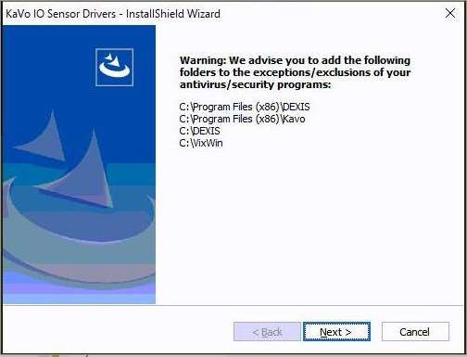

## Support

Dexis support can be contacted by calling 888-883-3947 Option 7